Name:
Date:
School:
Facilitator:

8.01 The Cube Root Function

State the vertex of each function.

1. | $$y=\sqrt[3]{x+5}-7$$ | Vertex: | ( , )
2. | $$y=-2\sqrt[3]{x+2}$$ | Vertex: | ( , )
3. | $$y=\sqrt[3]{3x-18}-8$$ | Vertex: | ( , )
4. | $$y=-\sqrt[3]{4x}-5$$ | Vertex: | ( , )

Explain how each new graph (in red) was transformed from the parent graph (in gray). Be as specific and detailed as possible. When stating the new vertex, make sure your b-value is 1 so you will correctly state the vertex.

5. | $$y=\sqrt[3]{x+4}-6$$ | New Vertex: ( , )
 | 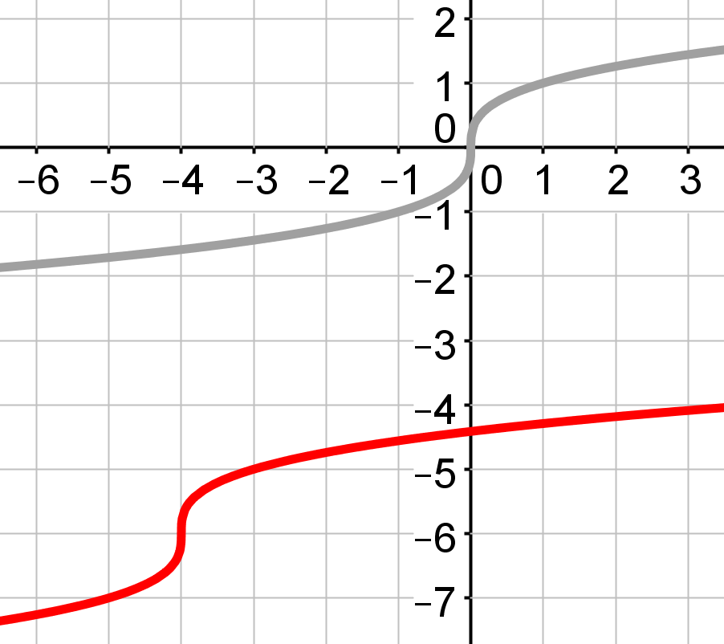
 | Description

6. | $$y=-2\sqrt[3]{2x+4}-5$$ | New Vertex: ( , )
 | 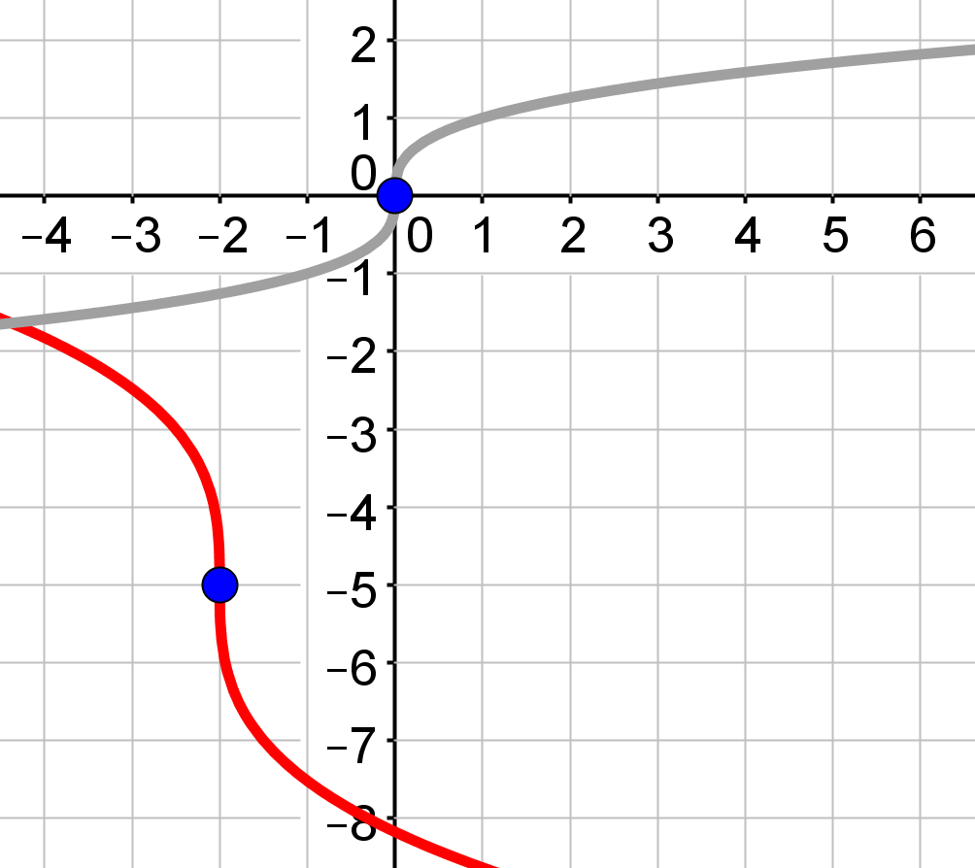
 | Description

7. | $$y=3\sqrt[3]{x}+4$$ | New Vertex: ( , )
 | 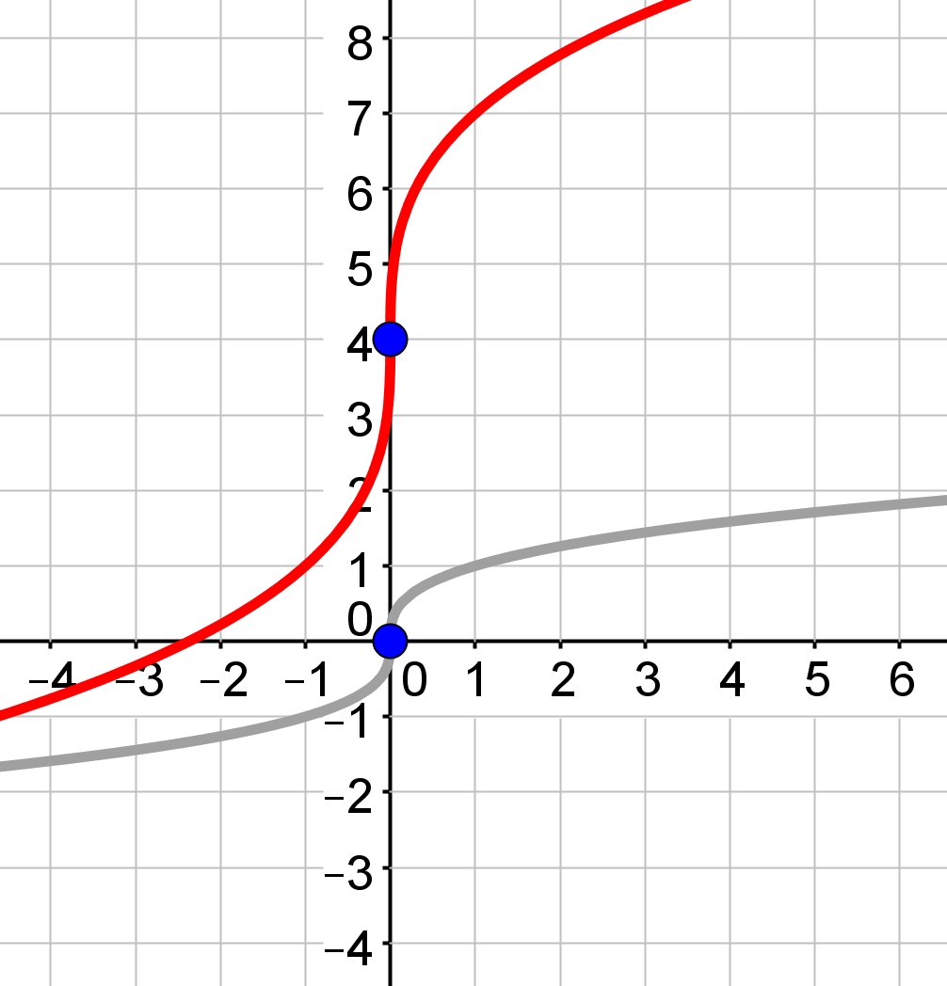
 | Description

8. | $$y=-\sqrt[3]{2x+2}+3$$ | New Vertex: ( , )
 | 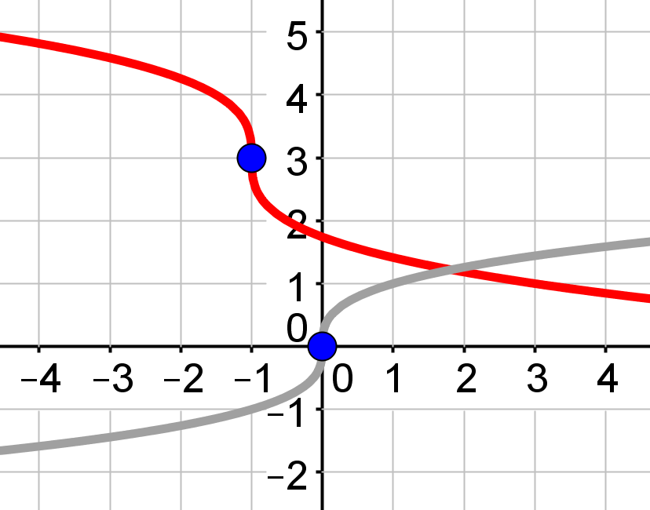
 | Description

Complete the x-y table for each of the following functions. Then, graph the function using GeoGebra. You will copy your graph from GeoGebra and paste it in the box provided. Be sure to resize your graph as needed. If you need help using GeoGebra, refer back to the lesson and watch the video.

9. | $$y=-\sqrt[3]{2x+2}-4$$ |  |  |  |  | Vertex: ( , )
 |  | x | y
 |  |  |  | Vertex Goes Here
 | Paste your graph here:

10. | $$y=2\sqrt[3]{x-1}+3$$ |  |  |  |  | Vertex: ( , )
 |  | x | y
 |  |  |  | Vertex Goes Here
 | Paste your graph here:

