Name:

Date:

School:

Facilitator:

**6.05 Applications of Quadratic Functions**

**A rocket is launch from the ground and the path of the rocket is modeled by the equation *h* = -4*t*2 – 80*t* where *h* represents the height of the rocket (in feet) after *t* seconds. Using the graph, answer each question.**

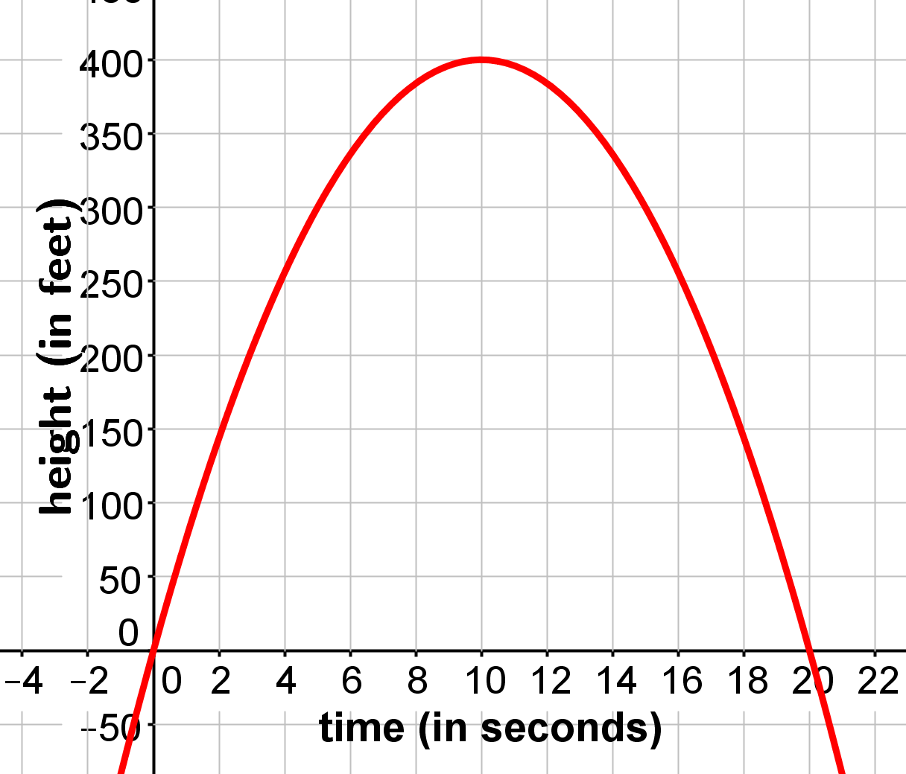

|  |  |  |  |
| --- | --- | --- | --- |
| 1. | How long does it take for the rocket to reach the ground? Be sure to include your units. | | |
|  |  | | |
|  |  |  |  |
| 2. | How did you determine your answer for #1? | | |
|  |  | | |
|  |  |  |  |
| 3. | What is the maximum height the rocket will reach? | | |
|  |  | | |
|  |  |  |  |
| 4. | How did you determine the maximum height in #3? Be specific. | | |
|  |  | | |
|  |  |  |  |
| 5. | How many seconds will it take for the rocket to reach its maximum height? | | |
|  |  | | |
|  |  |  |  |
| 6. | How did you determine how long it would take for the rocket to reach its maximum height in #5? Be specific. | | |
|  |  | | |

**A rocket carrying fireworks is launched from a hill above a lake. The rocket will fall into the lake after exploding at its maximum height. The rocket’s height above the surface of the lake is given by the function *h* = -16*t*2 + 64*t* + 80. In this function, *h* is the height of the rocket (in feet) and *t* is the amount of time (in seconds). Use this information to answer each question.**

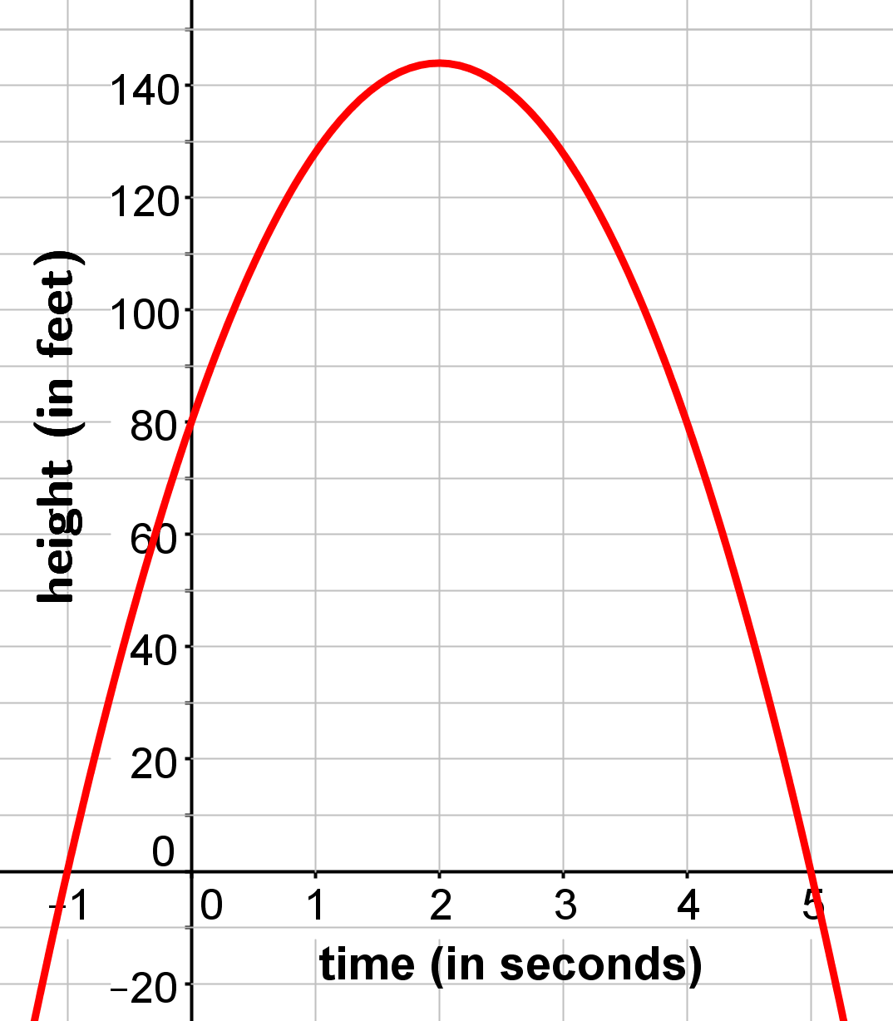

|  |  |  |  |  |  |  |  |
| --- | --- | --- | --- | --- | --- | --- | --- |
| 7. | Determine the maximum height of the rocket. Show your work. | | | | | | |
|  | *x* = – |  | = |  | = |  |  | |
|  |  |  |  | |
|  |  | |  | | | | |
|  | *h* = -16()2 + 64() + 80 | | | | | | |
|  | *h* = -16() +  + 80 | | | | | | |
|  | *h* =  +  + 80 | | | | | | |
|  | *h* = | | | | | | |
|  |  | |  | | | | |
|  | The rocket will reach its maximum height of  feet after  seconds. | | | | | | |
|  |  | |  | | | | |

|  |  |  |  |
| --- | --- | --- | --- |
| 8. | Using the quadratic formula, determine how long it will take for the rocket to reach the ground. | | |
|  |  | |  |
|  | $$x=\frac{-\left( FORMTEXT \right)±\sqrt{{\left( FORMTEXT \right)}^{2}-4\left( FORMTEXT \right)\left( FORMTEXT \right)}}{2\left( FORMTEXT \right)}$$ | |  |
|  |  | |  |
|  | $$x=\frac{- FORMTEXT ±\sqrt{ FORMTEXT -4\left( FORMTEXT \right)\left( FORMTEXT \right)}}{ FORMTEXT }$$ | |  |
|  |  | |  |
|  | $$x=\frac{- FORMTEXT ±\sqrt{ FORMTEXT - FORMTEXT }}{ FORMTEXT }$$ | |  |
|  |  | |  |
|  | $$x=\frac{- FORMTEXT ±\sqrt{ FORMTEXT }}{ FORMTEXT }$$ | |  |
|  |  | |  |
|  | $$x=\frac{- FORMTEXT ± FORMTEXT }{ FORMTEXT }$$ | |  |
|  |  | |  |
|  | $$x=\frac{- FORMTEXT + FORMTEXT }{ FORMTEXT }$$ | $$x=\frac{- FORMTEXT - FORMTEXT }{ FORMTEXT }$$ | |
|  |  |  | |
|  | *x* = seconds | *x* = seconds | |
|  |  |  | |
|  | One of the answers above will not be a possible answer. Which answer is not possible and why? | | |
|  | The answer *x* =  isn’t a possible answer because . | | |
|  |  |  | |
|  | The rocket will reach the ground after  seconds. | | |
|  |  |  | |
|  |  |  | |
| 9. | Predict the height of the rocket after 3 seconds. | | | |
|  | **Show work here:** | |  | |
|  | *h* = -16()2 + 64() + 80 | |  | |
|  | *h* = -16() +  + 80 | |  | |
|  | *h* =  +  + 80 | |  | |
|  | *h* =  feet | |  | |
|  |  | |  | |

**Farmer Joe wants to fence in a rectangular area that has one side bordered by a stream. If he has 80 meters of fencing, what are the dimensions and the maximum area he can enclose? The area of the fenced area can be found using the formula *A* = *lw* where *l* represents the length and *w* represents the width.**

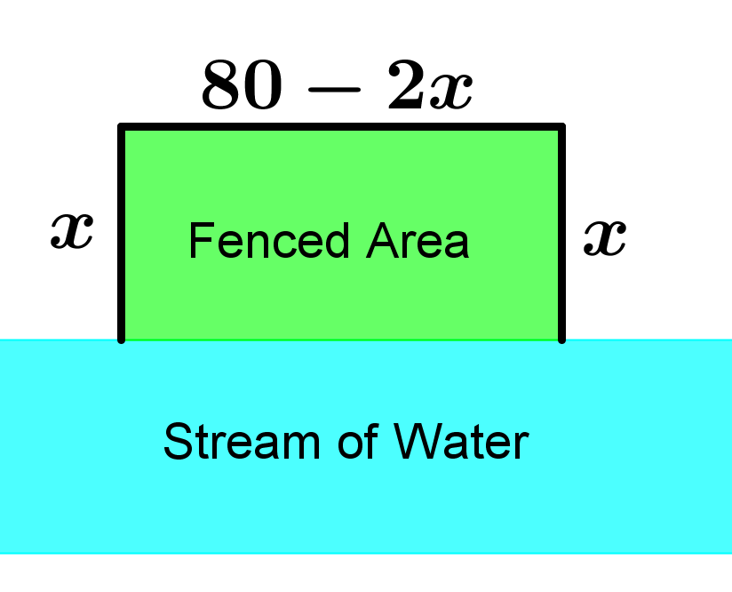

|  |  |  |  |  |  |  |  |  |
| --- | --- | --- | --- | --- | --- | --- | --- | --- |
| 10. | Substitute in the formula and simplify to find the function to find the maximum area. | | | | | | | |
|  | *A* = ()() | | | |  | | | | |
|  | *A* = | | |  | | | | |
|  |  | | |  | | | | |
| 11. | Find the value of *x* which is the value of the width. | | | | | | | |
|  | *x* = – |  | = |  | | = |  |  |
|  |  |  | |  |
|  |  |  | |  | | | | |
| 12. | Substitute into 80 – 2*x* and simplify to find the value of the length. | | | | | | | |
|  | *l* = 80 – 2() | | | | | | | |
|  | *l* = 80 – | | | | | | | |
|  | *l* =  meters | | | | | | | |
|  |  |  | |  | | | | |
| 13. | Substitute *x* = 20 into the function *A* = 80*x* – 2*x*2 to find the maximum area. | | | | | | | |
|  | *A* = 80() – 2()2 | | | | | | | |
|  | *A* =  – 2() | | | | | | | |
|  | *A* =  – | | | | | | | |
|  | *A* =  m2 | | | | | | | |
|  |  | | | | | | | |
|  | The conclusion is that the dimensions of the fenced area will be  meters by  meters and the maximum area of the fenced region is  square meters. | | | | | | | |
|  |  | | | | | | | |