Name:
Date:
School:
Facilitator:

5.03 Vertex Form of Quadratic Functions

Identify the vertex and axis of symmetry for each function.

1. | f(x) = 3(x + 3)² – 5 | Vertex: ( , ) | Axis of Symmetry: x =
2. | y = -4(x – 7)² + 3 | Vertex: ( , ) | Axis of Symmetry: x =
3. | y = (x – 12)² + 6 | Vertex: ( , ) | Axis of Symmetry: x =
4. | f(x) = -6(x + 7)² – 9 | Vertex: ( , ) | Axis of Symmetry: x =
5. | $$f\left(x\right)=-2\left(x-\frac{3}{4}\right)+\frac{2}{5}$$ | Vertex: ( , ) | Axis of Symmetry: x =

For each function, identify the vertex and axis of symmetry. Then, choose the correct graph for each function from the choices below. You will not use all of the graphs.

(A)  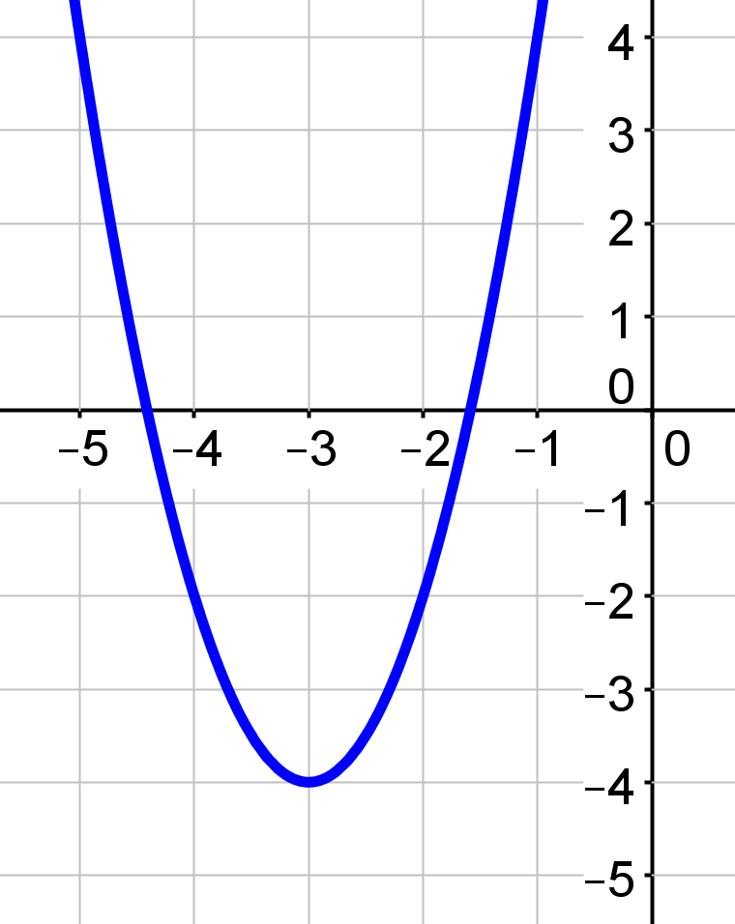 | (B)  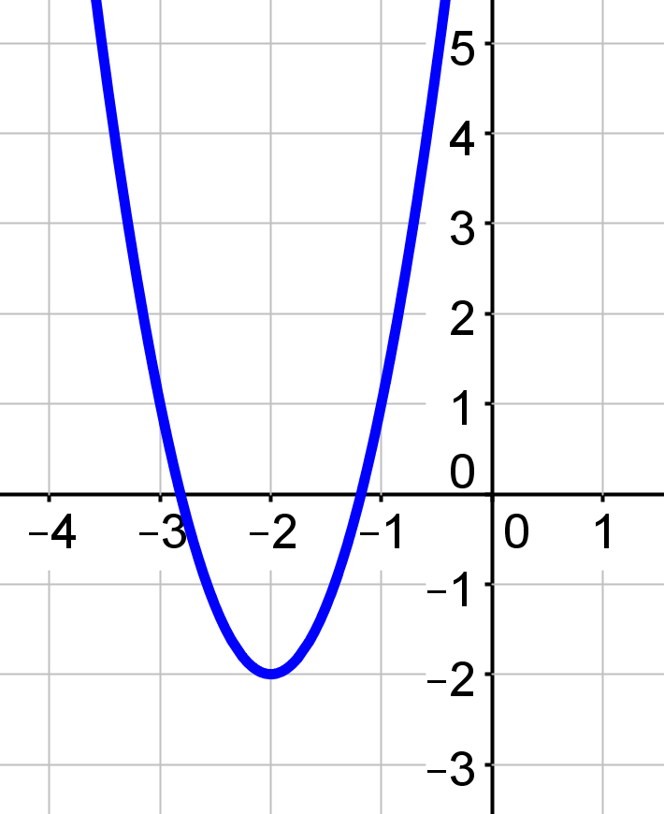 | (C)  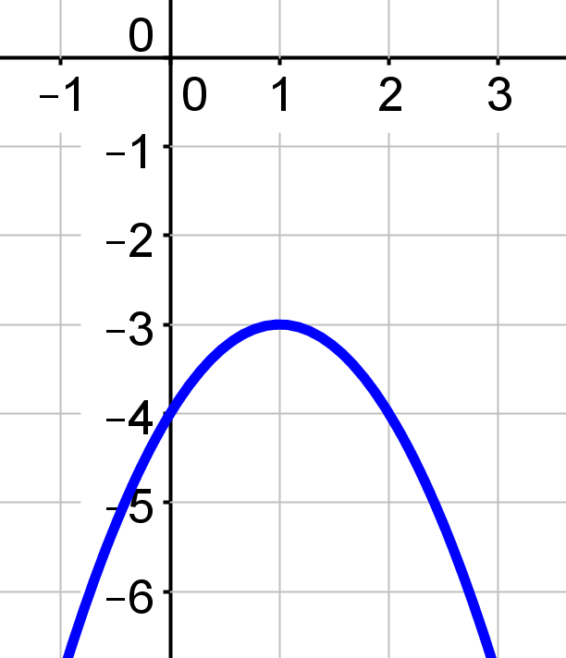
(D)  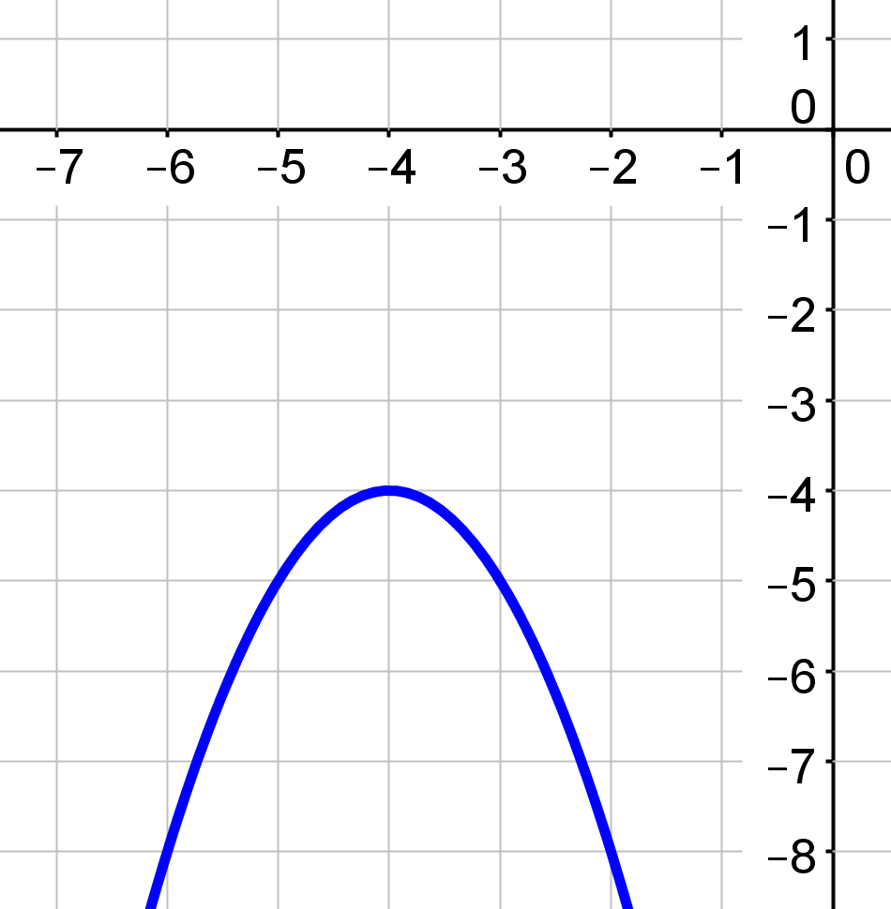 | (E)  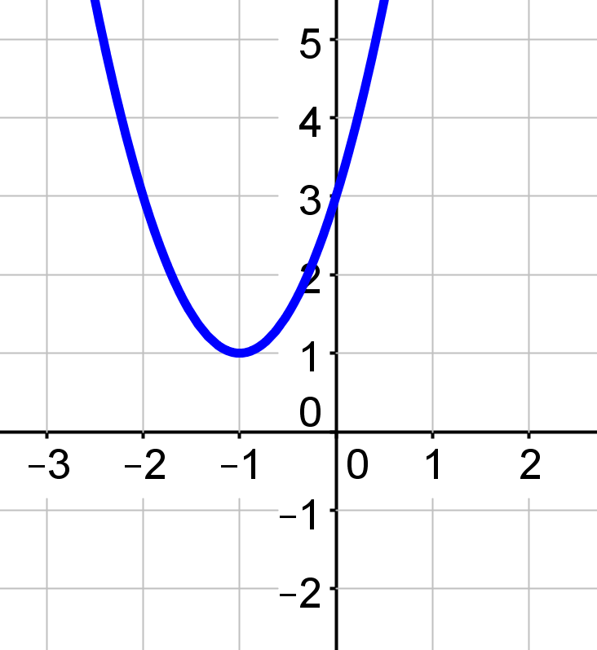 | (F)  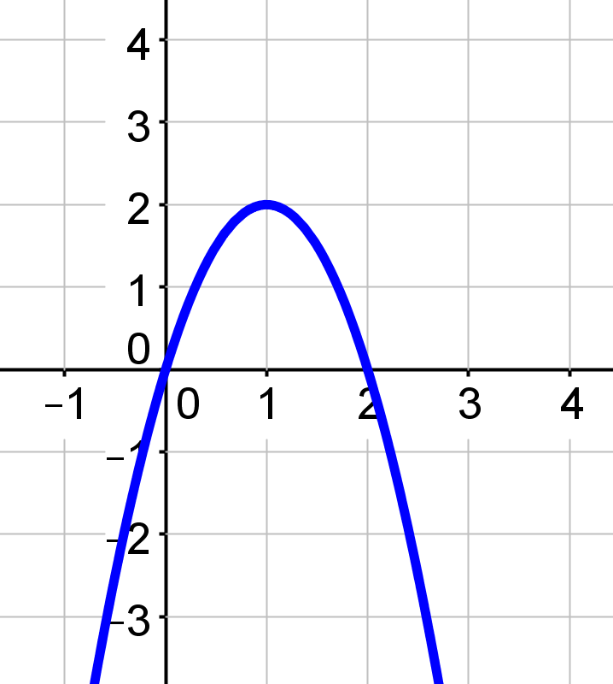

(G)  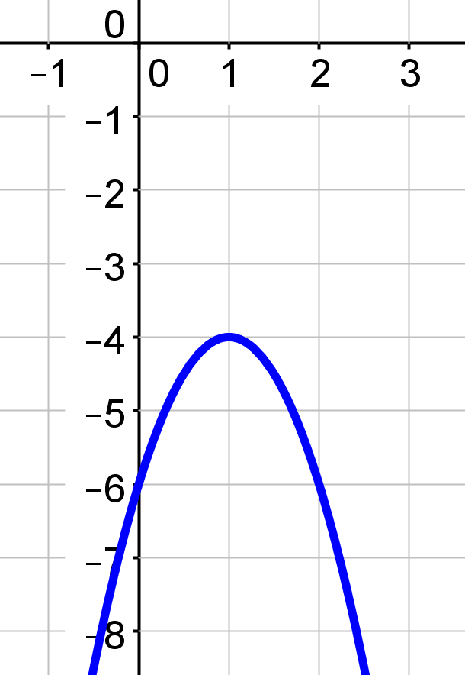 | (H)  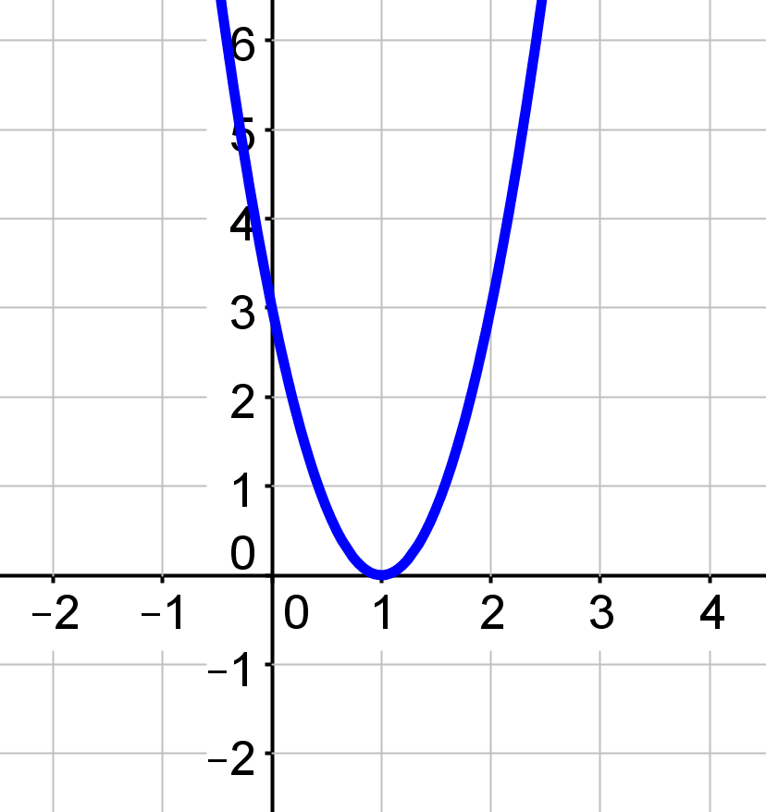 | (I)  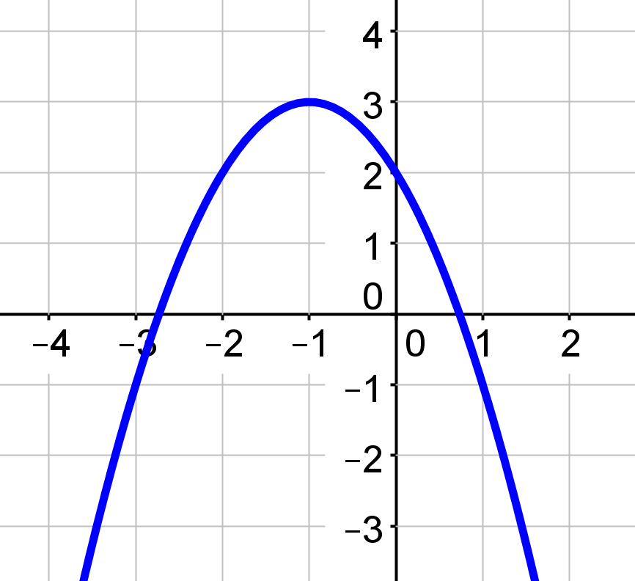

6. | y = -(x + 4)² – 4
 | Vertex: ( , ) | Axis of Symmetry: x = |  | Graph:
 | Show work for the second point here: |  | Second Point: ( , )

7. | y = 3(x – 1)²
 | Vertex: ( , ) | Axis of Symmetry: x = |  | Graph:
 | Show work for the second point here: |  | Second Point: ( , )

8. | f(x) = 2(x + 3)² – 4
 | Vertex: ( , ) | Axis of Symmetry: x = |  | Graph:
 | Show work for the second point here: |  | Second Point: ( , )

9. | y = 3(x + 2)² – 2
 | Vertex: ( , ) | Axis of Symmetry: x = |  | Graph:
 | Show work for the second point here: |  | Second Point: ( , )

10. | f(x) = -2(x – 1)² – 4
 | Vertex: ( , ) | Axis of Symmetry: x = |  | Graph:
 | Show work for the second point here: |  | Second Point: ( , )

Sarah and Michael are checking their homework and comparing answers. They encounter the problem with the function f(x) = -2(x – 1)² + 2. They both have the same vertex and axis of symmetry, but their graphs are different. Use this information to answer the questions that follow.
Sarah  Vertex: (1, 2)  Axis of Symmetry: x = 1 |  |  | Michael  Vertex: (1, 2)  Axis of Symmetry: x = 1  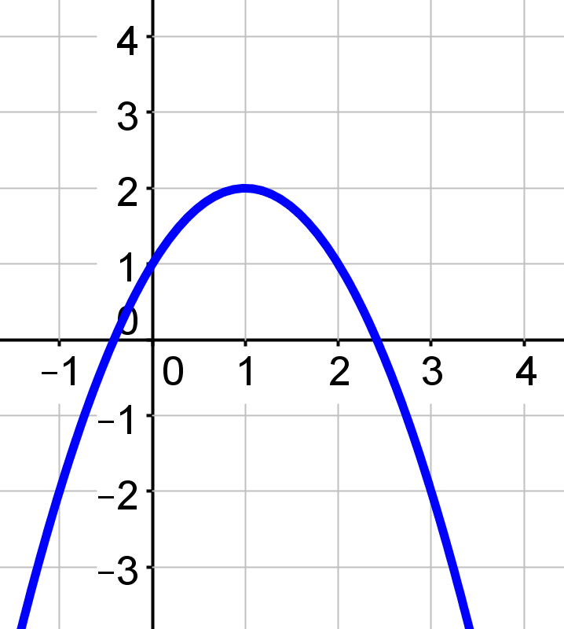
11. | Simply looking at the equation, can you make a prediction who is correct or incorrect or where the issue might occur with the answer?
12. | Are there any issues with Sarah’s answer? Be detailed in your answer if you find any errors.
13. | Are there any issues with Michael’s answer? Be detailed in your answer if you find any errors.
14. | If Sarah and Michael are working in a group and the teacher will accept one paper, which paper should the pair turn-in for their grade?

