Name:
Date:
School:
Facilitator:

3.03 Multiplying Monomials by Polynomials

Multiply each of the following to simplify the expression.

1. | 2x(5x + 6) | Answer:
 | Show work here:
2. | 5x(x² – x – 7) | Answer:
 | Show work here:
3. | -9n(4n² – 5n + 3) | Answer:
 | Show work here:
4. | 5x²(-2x² + 5x – 2) | Answer:
 | Show work here:
5. | -4x(2x² + 3x – 10) | Answer:
 | Show work here:
6. | 3x(4x² + 2x – 5) | Answer:
 | Show work here:
7. | 3m⁵(2m² + 4m³) | Answer:
 | Show work here:
8. | -12a⁶(8a³ – 2a² + 5a) | Answer:
 | Show work here:

Solve the following application problems. Show all work and write your final answers in the space provided.

9. | The area of a rectangle is found by the formula A = lw where l represents the length and w represents the width. Calculate the area of the rectangle below.  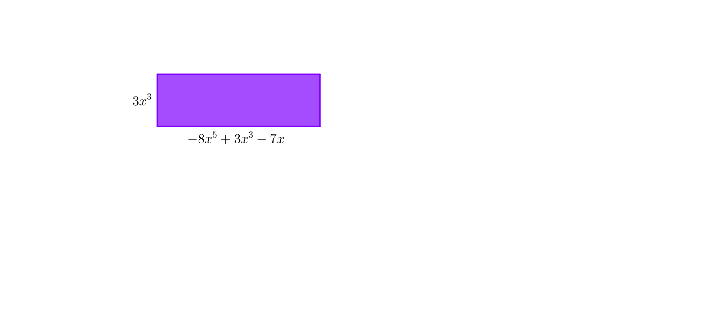
 | Show work here:
 | The area of the rectangle is A = .
10. | The area of a rectangle is found by the formula A = lw where l represents the length and w represents the width. Calculate the area of the rectangle below.  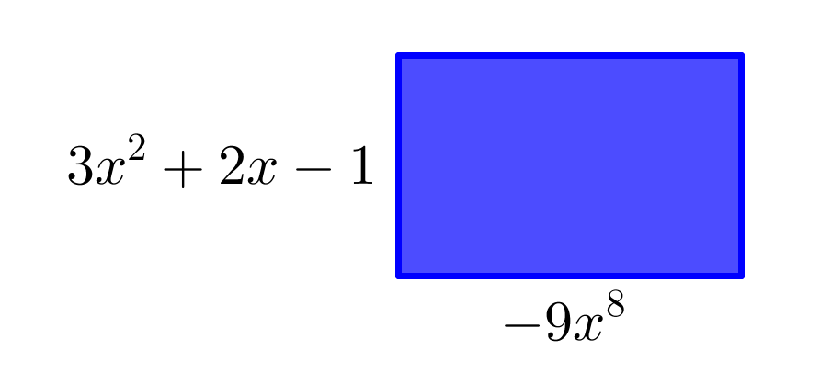
 | Show work here:
 | The area of the rectangle is A = .

