Name:

Date:

School:

Facilitator:

5.02 Relations and Functions

**Given each of the following relations, determine the domain, range, and whether or not the relation represents a function. If the relation is not a function, explain why it does not represent a function. If the relation represents a function, write “n/a” for the explanation.**

|  |  |  |
| --- | --- | --- |
| 1. {(-2, 2), (0, 5), (1, 6), (1, 7), (2, 1)}  Domain:  Range:  Function? (Yes or No):  Explanation: |  | 2. {(0, 1), (2, 1), (3, 2), (4, -2), (-5, 1), (6, -4)}  Domain:  Range:  Function? (Yes or No):  Explanation: |
|  |  |  |
| 3. {(0, -5), (-6, 1), (0, 0), (4, -12), (-3, -2)}  Domain:  Range:  Function? (Yes or No):  Explanation: |  | 4. {(*x*, *y*), (*a*, *n*), (*m*, *c*), (*m*, *n*)}  Domain:  Range:  Function? (Yes or No):  Explanation: |

**Determine which of the following graphs would be a function or not a function.**

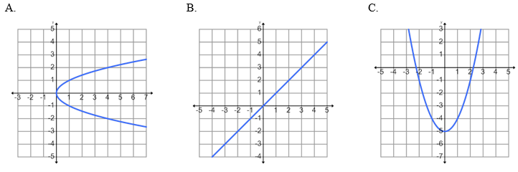

|  |  |  |  |  |
| --- | --- | --- | --- | --- |
|  |  |  |  |  |
|  |  |  |  |  |
|  |  |  |  |  |

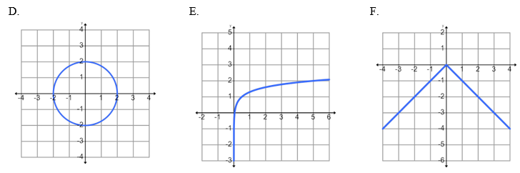

5. Which of the graphs above **represent a function**?

6. Which of the graphs above **do not represent a function**?

|  |  |
| --- | --- |
| 7. | Evaluate to determine *f*(5) if *f*(*x*) = 3*x* – 2*x*². Show all work.  *f*(5) = |
|  | **Show work here:** |
|  |  |
|  |  |
| 8. | Determine the range value for the function *m*(*x*) = -3*x* + 10 if the domain value is 10. Show all work.  Range value = |
|  | **Show work here:** |
|  |  |
|  |  |
| 9. | Determine the range value for the function *g*(*x*) = -9*x*² – 9 if the domain value is -6. Show all work.  Range value = |
|  | **Show work here:** |
|  |  |
|  |  |
| 10. | Evaluate to determine *h*(20) if *h*(*x*) = -5*x* + 2. Show all work.  *h*(20) = |
|  | **Show work here:** |
|  |  |
|  |  |