Name:

Date:

School:

Facilitator:

9.05 Calculating Surface Area and Volume of Irregular Shapes

# Part 1: Surface Area

**Find the surface area of the following 10 shapes. Leave answers in terms of π when needed.**

1. Surface area:

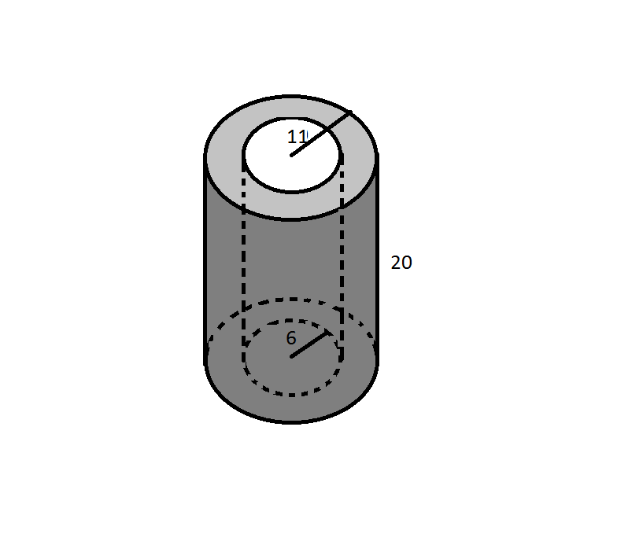

1. Surface area:

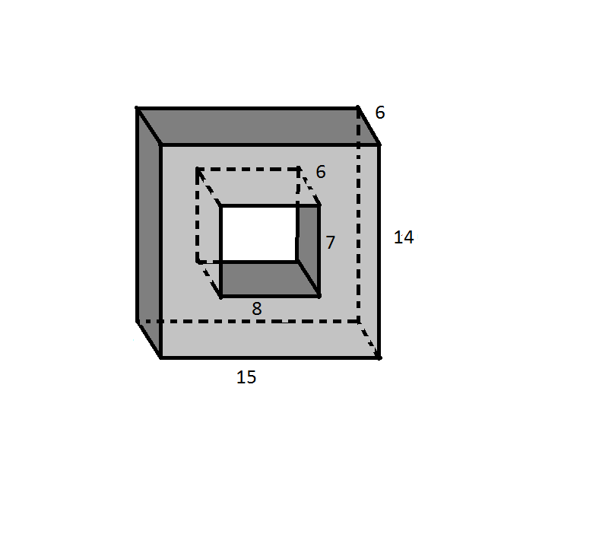

1. Surface area:

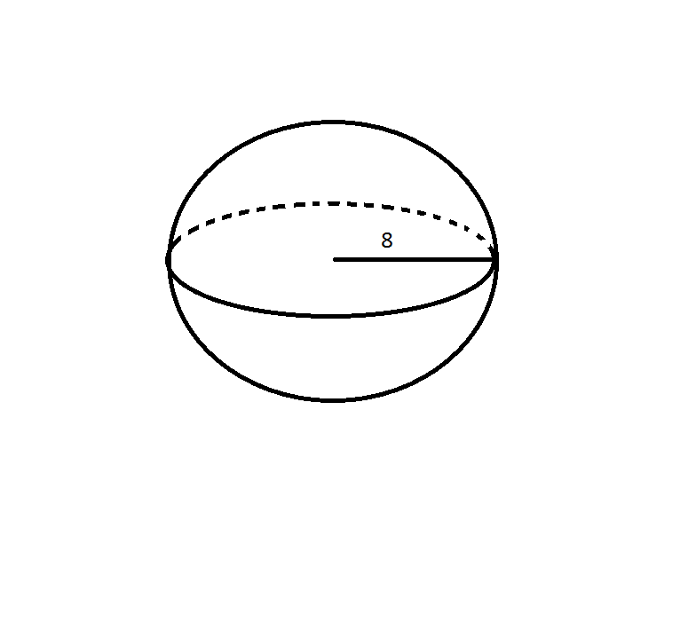

1. Surface area:

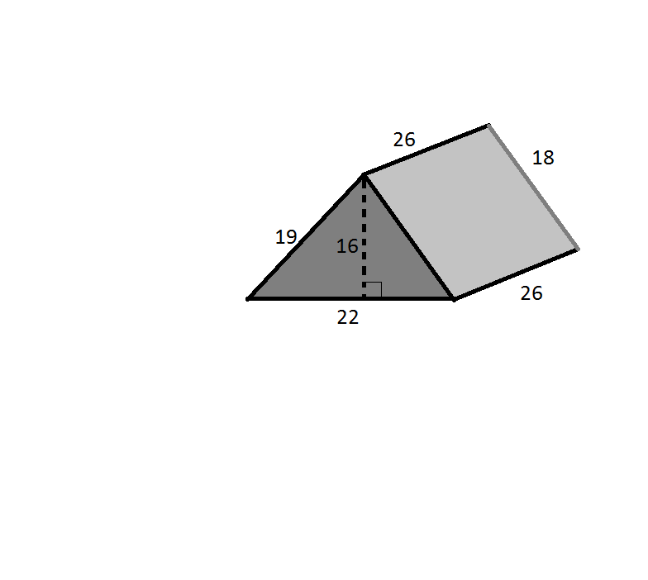

1. Surface area:

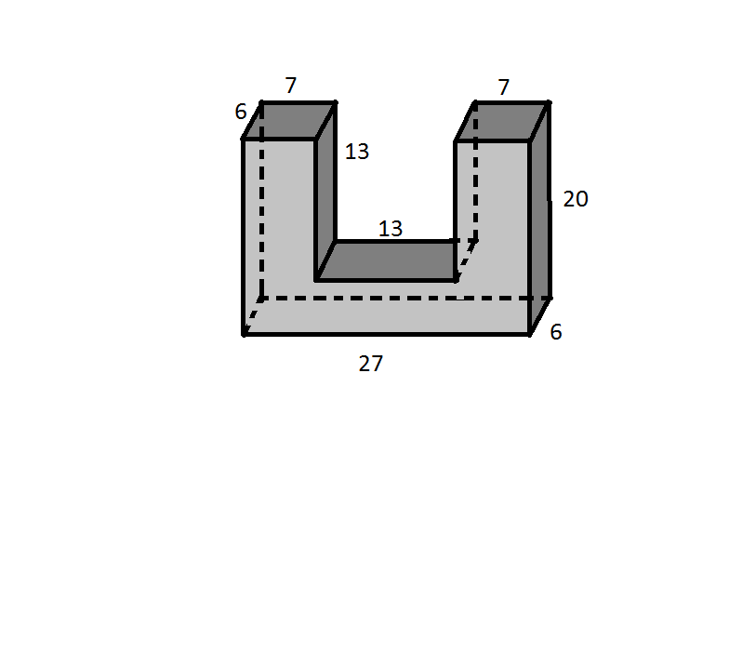

1. Surface area:

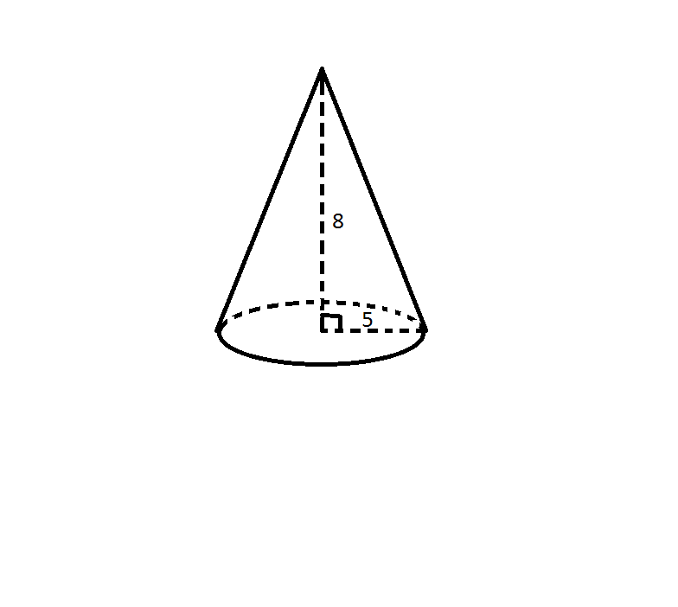

1. Surface area:

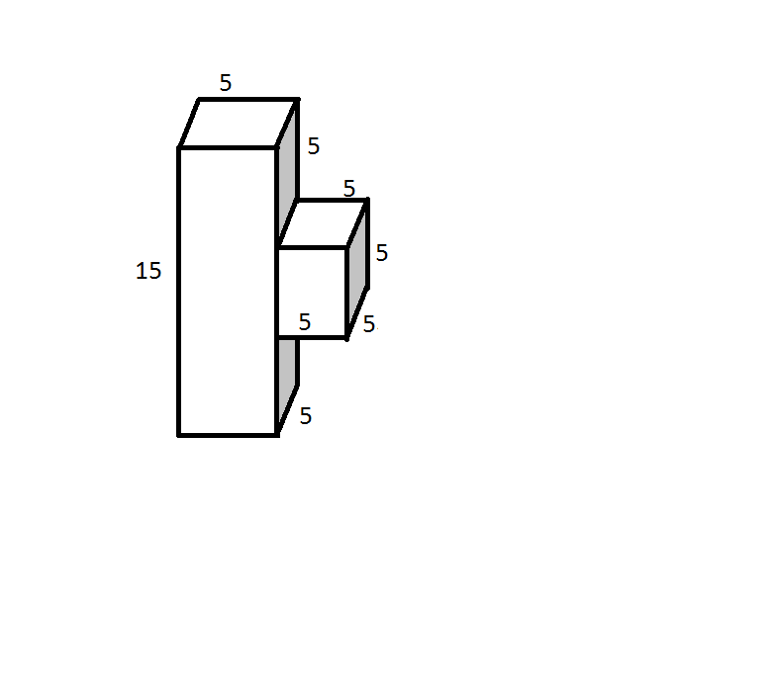

1. Surface area:

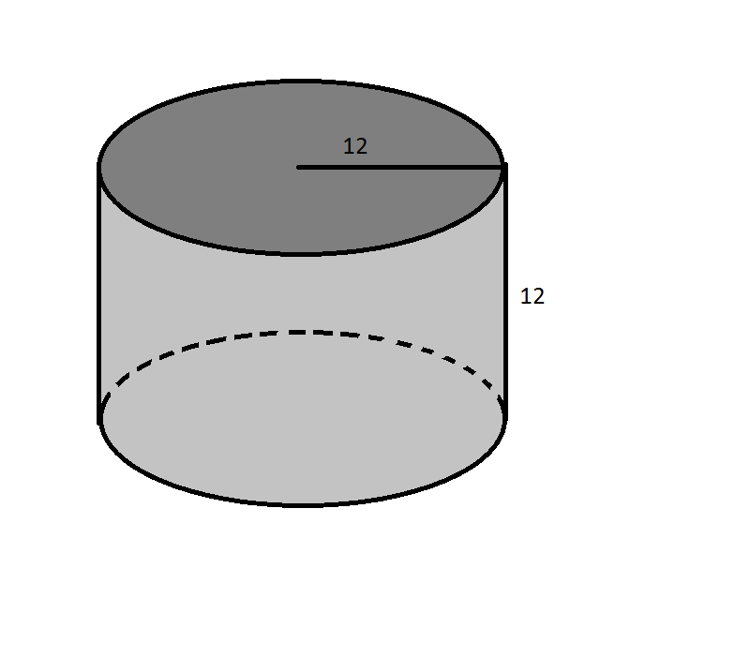

1. Surface area:

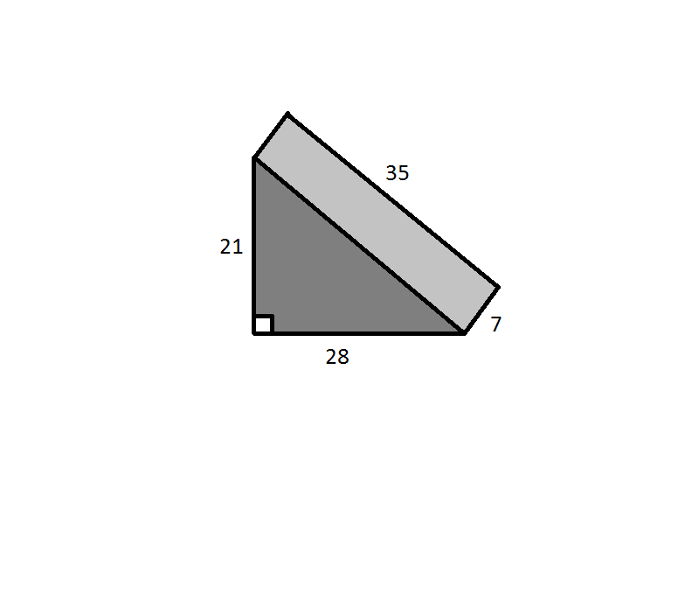

1. Surface area:

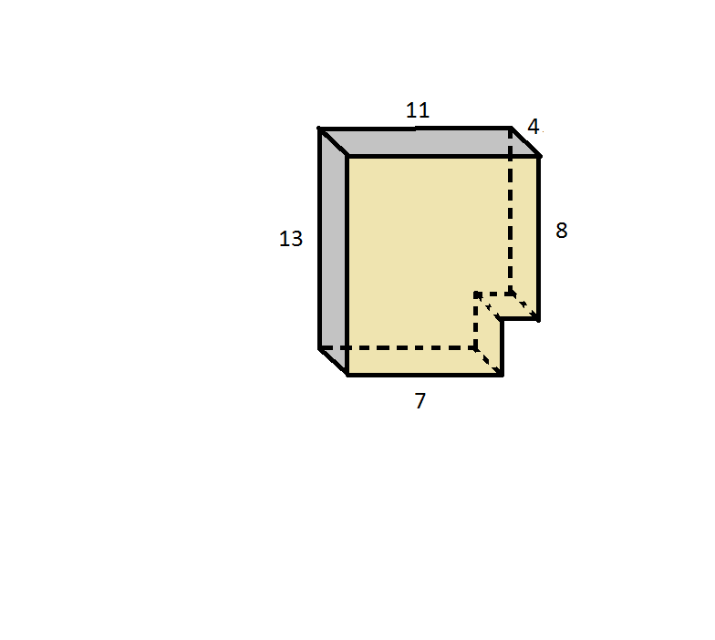

# Part 2: Volume

**Find the volume of the following shapes. Leave answers in terms of π when needed.**

1. Volume:



1. Volume:



1. Volume:



1. Volume:



1. Volume:



1. Volume:



1. Volume:



1. Volume:



1. Volume:



1. Volume:

