Name:

Date:

School:

Facilitator:

9.01 Tile Calculations

# ****Part 1: Area****

**Find the area of each tile in square feet.**

1. 6 inches by 6 inches =
2. 18 inches by 18 inches =
3. 6 inches by 24 inches =

# ****Part 2: Room 1****

**You will be tiling the floor below with 6 inch by 12 inch tiles. You will need to figure 15% overage for this job.**

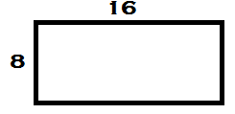

1. What is the area of the floor?

1. What is the area of each tile in square feet?

1. How many tiles will you need to purchase?

# ****Part 3: Room 2****

**You will be tiling the floor below with 12 inch by 12 inch tiles. You will need to figure 20% overage for this job.**

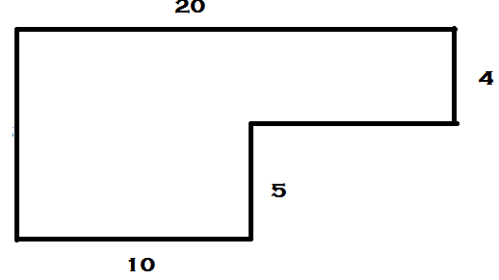

1. What is the area of the floor?

1. How many tiles will you need to purchase?

# Part 4: Room 3

**You will be tiling the floor below with 6 inch by 6 inch tiles. You will need to figure 15% overage for this job.**

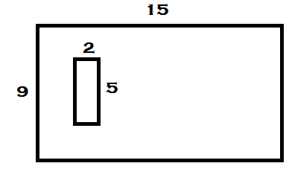

1. What is the area of the floor to be tiles?

1. How many tiles will you need to purchase?