Name:

Date:

School:

Facilitator:

7.07 Real Life Mean, Median, and Mode

# ****Part 1: Tally Marks****

**The table below uses tally marks to show the results of a survey rating the service in a local restaurant.**

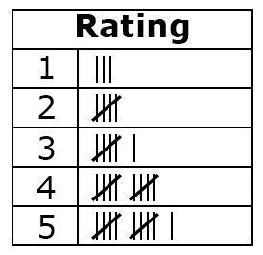

1. What is the mode?

2. What is the median?

3. What is the mean?

# Part 2: High Temps

**The high temperatures for the past week were: 98, 85, 90, 88, 103, 100, and 98. Find the mode, median, and mean of this set of data.**

4. What is the mode?

5. What is the median?

6. What is the mean?

# ****Part 3: Newborns****

**There were 6 babies born at the local hospital today. Their weights were: 5.5 lb, 6.7 lb, 7.8 lb, 6.8 lb, 6.7 lb, and 7.8 lb. Find the mode, median, and range of this set of data.**

7. What is the mode?

8. What is the median?

9. What is the mean?

# ****Part 4: Test Scores****

**10. Zayne has scores of 65, 95, 89, 100, and 98. What does he need to score on his next test to pull his average up to a 90?**