Name:

Date:

School:

Facilitator:

6.04 Scatter Plots and Regression Lines

**To answer some of the questions below, you will need to use GeoGebra, which is linked on the Task page.**

1. The success of a shopping center can be represented as a function of the distance (in miles) from the center of the population and the number of clients (in hundreds of people) who will visit. The data is given below.

|  |  |
| --- | --- |
| **Number of Customers**  **(in hundreds)** | **Distance**  **(in miles)** |
| 8 | 15 |
| 7 | 19 |
| 6 | 25 |
| 4 | 23 |
| 2 | 34 |
| 1 | 40 |

(A) Drag the points to create a scatterplot for this data.

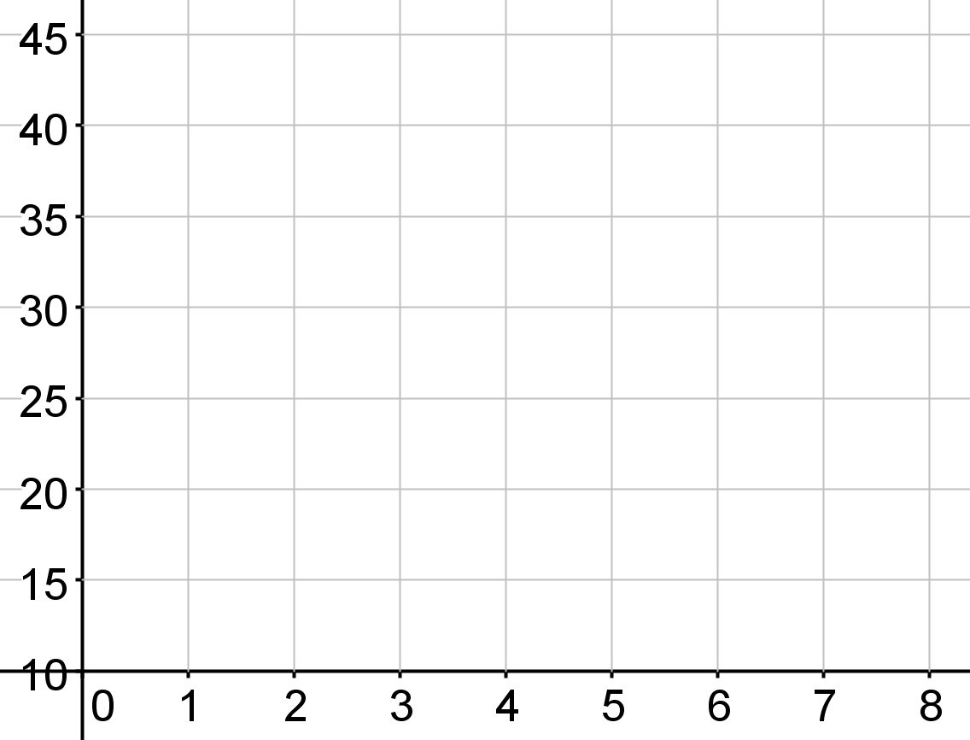

|  |  |
| --- | --- |
| (B) | Using GeoGebra, determine the regression equation. *y* =      *x* + |
|  |  |
| (C) | To receive 300 customers (*x* = 3), what distance from the center of the population should the shopping center be located? Show your work below. |
|  | The shopping center should be located       miles from the center of the population to receive 300 customers. |
|  | **Show work here:** |
|  |  |
|  |  |
| (D) | To receive 500 customers (*x* = 5), what distance from the center of the population should the shopping center be located? Show your work below. |
|  | The shopping center should be located       miles from the center of the population to receive 500 customers. |
|  | **Show work here:** |
|  |  |
|  |  |
| (E) | Would this be an example of positive, negative, or exponential correlation? |
|  |  |

2. The weight of 5 children is listed below. Use this information to answer the questions and create a scatterplot of this data.

|  |  |
| --- | --- |
| **Age**  **(in years)** | **Weight**  **(in kilograms)** |
| 2 | 14 |
| 3 | 20 |
| 5 | 32 |
| 7 | 42 |
| 8 | 44 |

(A) Use the data above to create a scatterplot. Drag the points onto the graph to create your scatterplot.



|  |  |
| --- | --- |
| (B) | Using GeoGebra, determine the regression equation. *y* =      *x* + |
|  |  |
| (C) | Based on the data, what is the approximate weight of a child who is 4 years old? Show your work below. |
|  | A child who is 4 years old would weight approximately       kilograms. |
|  | **Show work here:** |
|  |  |
|  |  |
| (D) | Based on the data, what is the approximate weight of a child who is 10 years old? Show your work below. |
|  | A child who is 10 years old would weight approximately       kilograms. |
|  | **Show work here:** |
|  |  |
|  |  |
| (E) | Would this be an example of positive, negative, or exponential correlation? |
|  |  |