Name:

Date:

School:

Facilitator:

3.05 Graphing Linear and Piecewise Functions

1. Graph the following piecewise function: See the task page for your graphing options.

{

x + 4 ; x < -2

f(x) = -x ; -2 < x < 2

x – 4 ; x > 2

|  |
| --- |
|  |

2. Graph the following piecewise function: See the task page for your graphing options.

f(x) = |x – 1| + 1

Vertex:       Slope 1:       Slope 2:

|  |
| --- |
|  |

3. The table lists postage for letters weighing as much as 3 oz. You want to mail a letter that weighs 2.1 oz. Graph the step function by dragging the lines and shapes to the graph area. How much will you pay in postage?

|  |  |
| --- | --- |
| **Weight Up To** | **Price** |
| 1 oz | $0.40 |
| 2 oz | $0.65 |
| 3 oz | $0.90 |

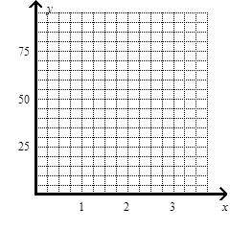

Postage price:      

4. The table lists postage for letters weighing as much as 3 oz. You want to mail a letter that weighs 1.8 oz. Graph the step function by dragging the lines and shapes to the graph area. How much will you pay in postage?

|  |  |
| --- | --- |
| **Weight Up To** | **Price** |
| 1 oz | $0.40 |
| 2 oz | $0.57 |
| 3 oz | $0.74 |

  
Postage price:      

5. The table lists postage for letters weighing as much as 3 oz. You want to mail a letter that weighs 2.8 oz. Graph the step function by dragging the lines and shapes to the graph area. How much will you pay in postage?

|  |  |
| --- | --- |
| **Weight Up To** | **Price** |
| 1 oz | $0.49 |
| 2 oz | $0.70 |
| 3 oz | $0.91 |

  
Postage price: