Name:

Date:

School:

Facilitator:

1.07 Absolute Value Functions

This task requires you to create a graph. You have several options:

* Use the word tools;
* Draw the graph by hand, then photograph or scan your graph; or
* Use the GeoGebra linked on the Task page of the lesson to create the graph, then insert a screenshot of the graph into this task.

**Determine the vertex of each absolute value function, state whether the vertex is a maximum or minimum point, determine the opening of the graph, graph each function, and describe the translation.**

1. *f*(*x*) = |*x*| – 4

Vertex:       Maximum or minimum?:

Opens:      

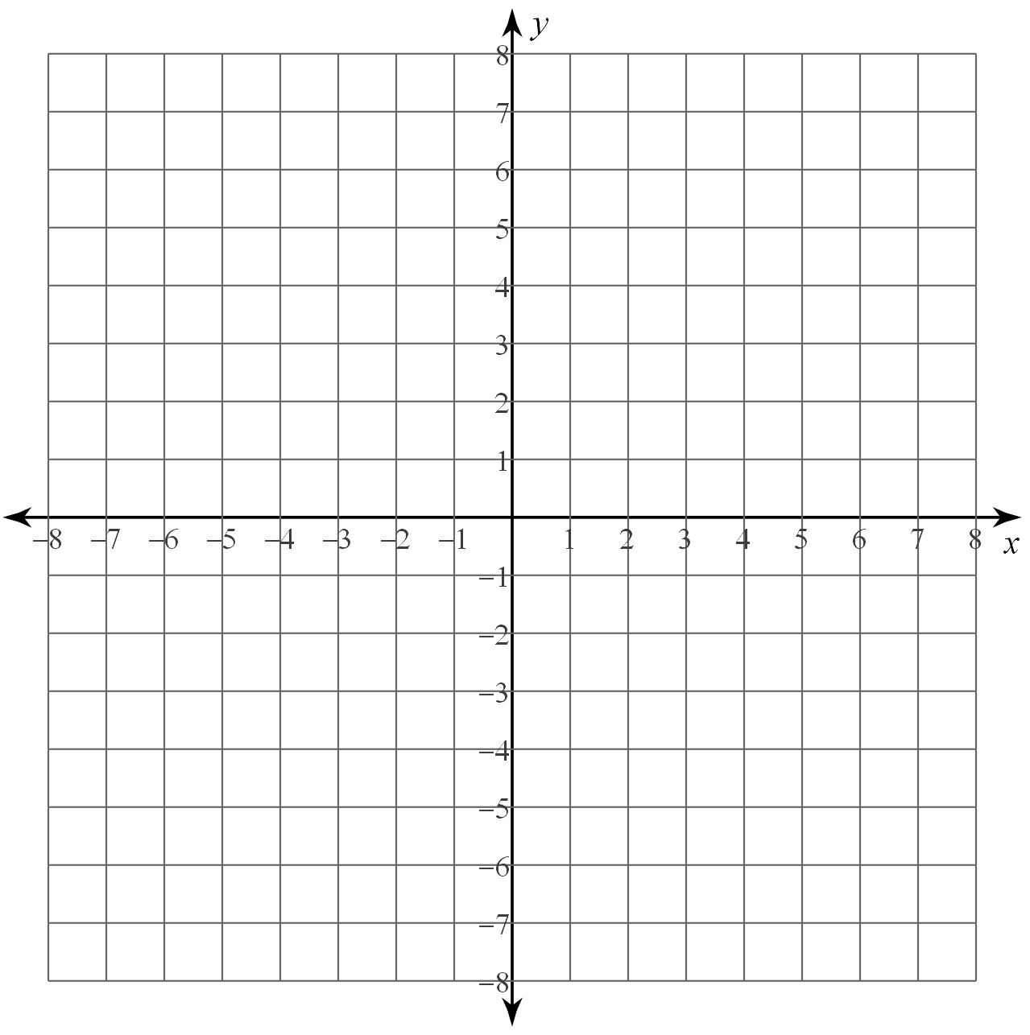

Describe the translation:

2. *f*(*x*) = -|*x* – 5| + 3

Vertex:       Maximum or minimum?:

Opens:



Describe the translation:

3. *f*(*x*) = |*x* + 2| – 3

Vertex:       Maximum or minimum?:

Opens:



Describe the translation:

4. *f*(*x*) = -|*x* – 2| – 3

Vertex:       Maximum or minimum?:

Opens:



Describe the translation:

5. When comparing the graph of g(x) and the equation of f(x), which function has a larger maximum? Explain why.

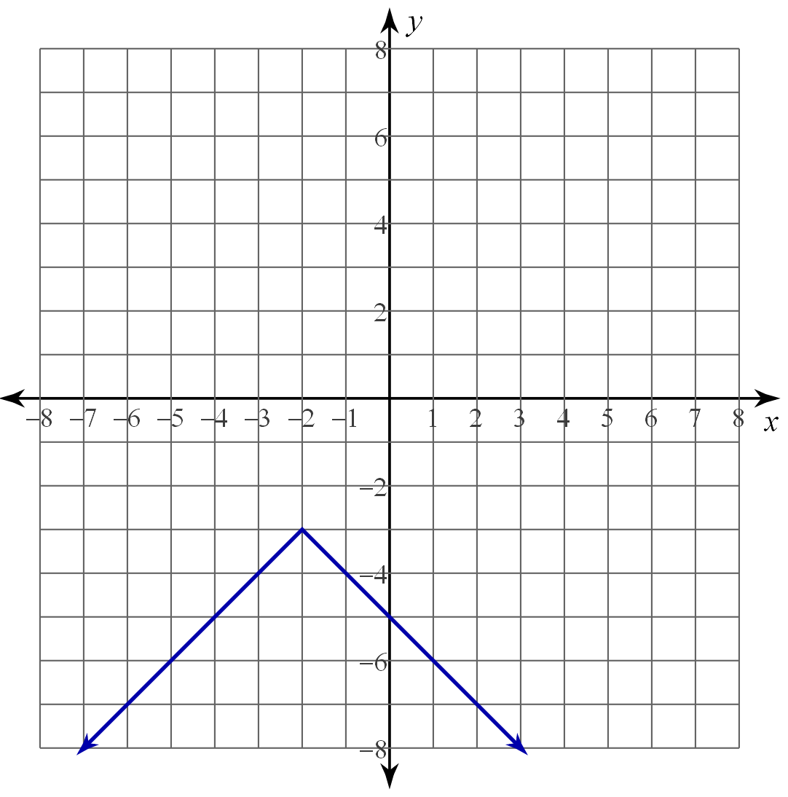 g(x)

6. If and the graph of h(x) translates right 3 and up 2, which function has a smaller minimum? Explain why.

7. Rewrite as a piecewise function.

$f\left(x\right)=\left\{\begin{aligned} FORMTEXT , &x< FORMTEXT \\ FORMTEXT , &x≥ FORMTEXT \end{aligned}\right.$