Name:

Date:

School:

Facilitator:

1.06 Step Functions

This task requires you to create a graph. You have several options:

* Use the word tools;
* Draw the graph by hand, then photograph or scan your graph; or
* Use the GeoGebra linked on the Task page of the lesson to create the graph, then insert a screenshot of the graph into this task.

**You are mailing a package and the post office has the following sign posted which tells you their pricing. Use the chart to answer questions 1-3.**

|  |  |
| --- | --- |
| **Cost** | **Weight (in lbs)** |
| $6.00 | 0 < weight ≤ 5 |
| $8.00 | 5 < weight ≤ 8 |
| $10.00 | 8 < weight ≤ 12 |
| $15.00 | 12 < weight ≤ 20 |

|  |  |
| --- | --- |
| **1**. | How much would it cost to mail a package weighing 13 lbs.? |
|  | $ |
|  |  |
| **2**. | How much would it cost to mail a package weighing 3 lbs.? |
|  | $ |
|  |  |
| **3**. | How much would it cost to mail a package weighing 12 lbs.? |
|  | $ |

Continued on the next page

**4. Graph the following equations with the given constraints. Drag the lines and points as appropriate. You may not use all of the points provided.**

*y* = 2*x* + 3 -3 ≤ *x* ≤ 0

*y* = 3 0 ≤ *x* ≤ 2

*y* = 4x -5 2 ≤ *x* ≤ 5

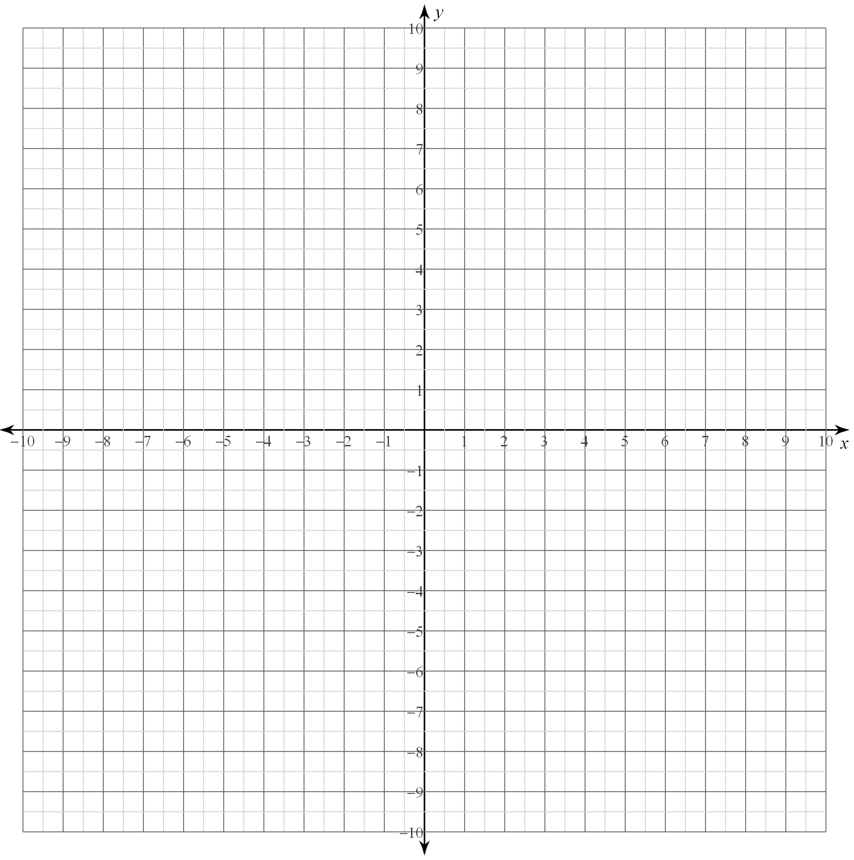

Continued on the next page

**5. Graph the following equations with the given constraints.**

*y* = 1 -5 ≤ *x* < -1

*y* = 2 -1 ≤ *x* < 3

*y* = 3 3 ≤ *x* < 7

