Name:

Date:

School:

Facilitator:

1.05 Linear Equations and Inequalities

This task requires you to create a graph. You have several options:

* Use the word tools;
* Draw the graph by hand, then photograph or scan your graph; or
* Use the GeoGebra linked on the Task page of the lesson to create the graph, then insert a screenshot of the graph into this task.

**Drag the lines to the graph and adjust the ends as necessary. If you have a tablet, you can draw directly on the coordinate plane.**

**1.** Graph: y = 2x – 4

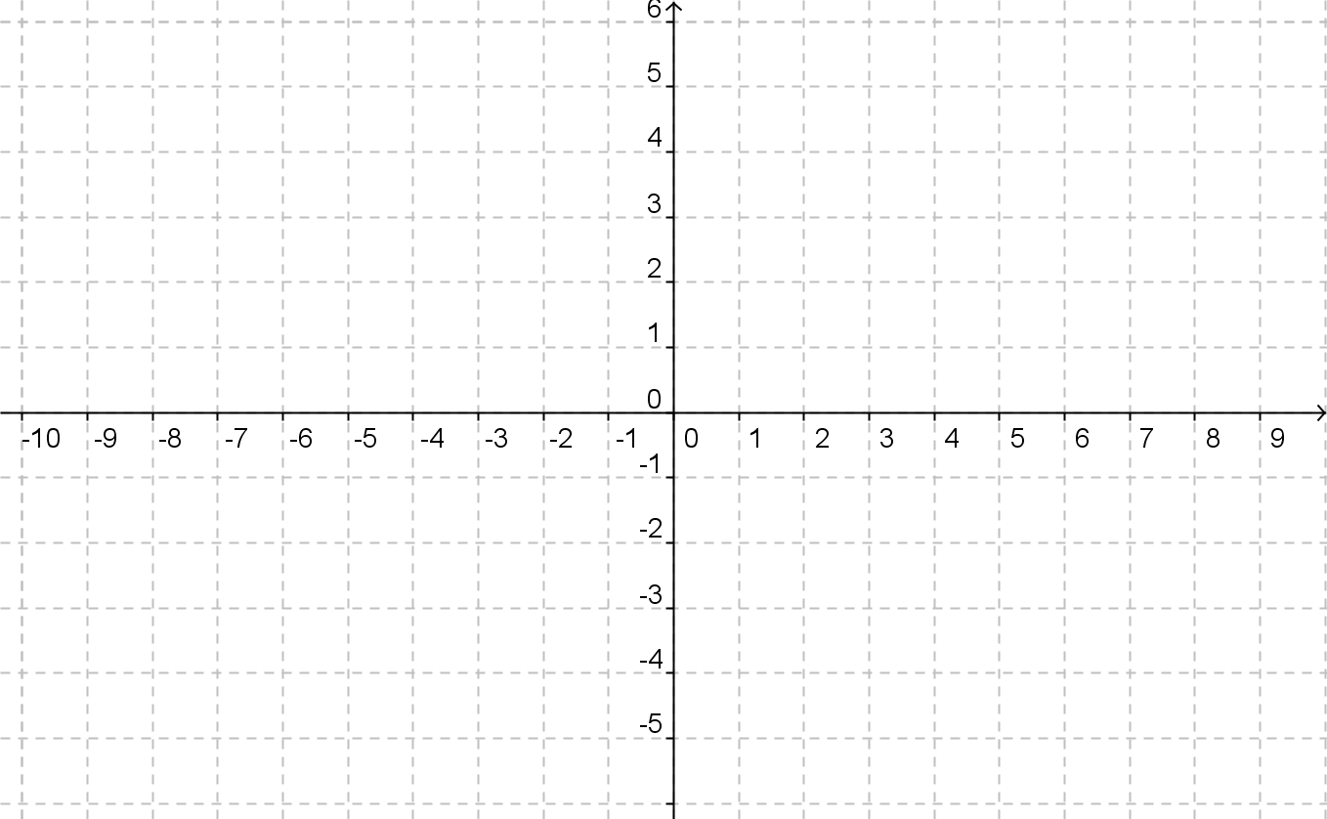

**2.**  Graph: $y=\frac{1}{3 }x-2$



**3.** Graph: 3x - 5y = 15



**4.**  Graph: 2x – y = 4



**Drag the lines to the graph and adjust the ends as necessary. If you have a tablet, you can draw directly on the coordinate plane. The extra lines should be used to indicate the shaded side of the graph.**

**5.** Graph: y < 3x – 4



**6.**  Graph: 



**7.**  Graph: $y<-\frac{3}{4 }x+2$

