Name:

Date:

School:

Facilitator:

8.05 Transforming Reciprocal Functions (56 Points)

# Transforming Piecewise Functions

**Write an equation for the transformation of each reciprocal function described below.**

1.Stretch by a factor of 4 and translate up 7:

2. Translate right 5, up 7 and reflect over the x-axis:

3. Stretch by a factor $\frac{1}{2}$, translate left 3 and up 8:

4. Translate left 8, down 9 and reflect over the *x*-axis:

5. Translate 3 units up and shrink by a factor of .

6. Translate 6 left, up 10 and reflect over the *y*-axis: $f\left(x\right)=$

# Reciprocal

**Graph the reciprocal function, graph the transformation and analyze the key features of both.**

7. $$f\left(x\right)= \frac{1}{x}-5$$

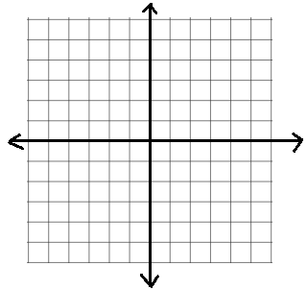

* **Original**
  1. Domain:
  2. Range:
  3. *x*-asymptote:
  4. *y*-asymptote:
  5. Center:
  6. Odd:
* **Translate:**
  1. Domain:
  2. Range:
  3. *x*-asymptote:
  4. *y*-asymptote:
  5. Center:
  6. Odd:

8. $$f\left(x\right)= \frac{2}{x+3}$$



* **Original**
  1. Domain:
  2. Range:
  3. *x*-asymptote:
  4. *y*-asymptote:
  5. Center:
  6. Odd:
* **Translate:**
  1. Domain:
  2. Range:
  3. *x*-asymptote:
  4. *y*-asymptote:
  5. Center:
  6. Odd: