Name:

Date:

School:

Facilitator:

7.05 Graphs of Cosecant and Secant (30 points)

**Read each question and fill-in your answer for the blank provided.**

1. Secant is the reciprocal of the       trigonometric function.
2. The      function is the reciprocal of the sine trigonometric function.
3. Neither cosecant nor secant have a(n)       because the graph does not have a height as it approaches infinity.
4. To determine the horizontal shift of a cosecant or secant graph, we will look at the “     ” term to determine its value.
5. To determine the period of a cosecant or secant graph, we will look at the “     ” term to determine its value.

**Using each of the following equations determine the period.**

1. y equals 5 the secant of open paren 2 x minus pi over 6 close paren

Period =

$y= -2\csc{(x+2})$

Period =

1. 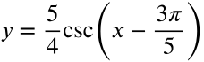

Period =

1. 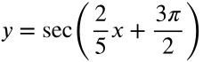

Period =

$y= \sec{(4x-2)}$

Period =

**Using the graph below, determine the period and horizontal shift. The graph of the dotted line represents the graph of y = Acsc(Bx) or y = Asec(Bx).**

11. Value of A =       Value of B =       Period =       Equation: *y*=     csc(     *x*)

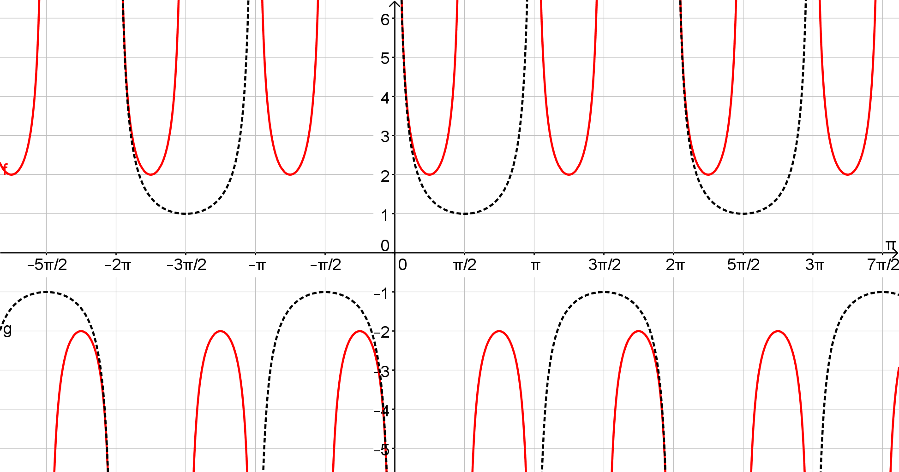

12. Value of A =       Value of B =       Period =       Equation: *y*=     csc(     *x*)

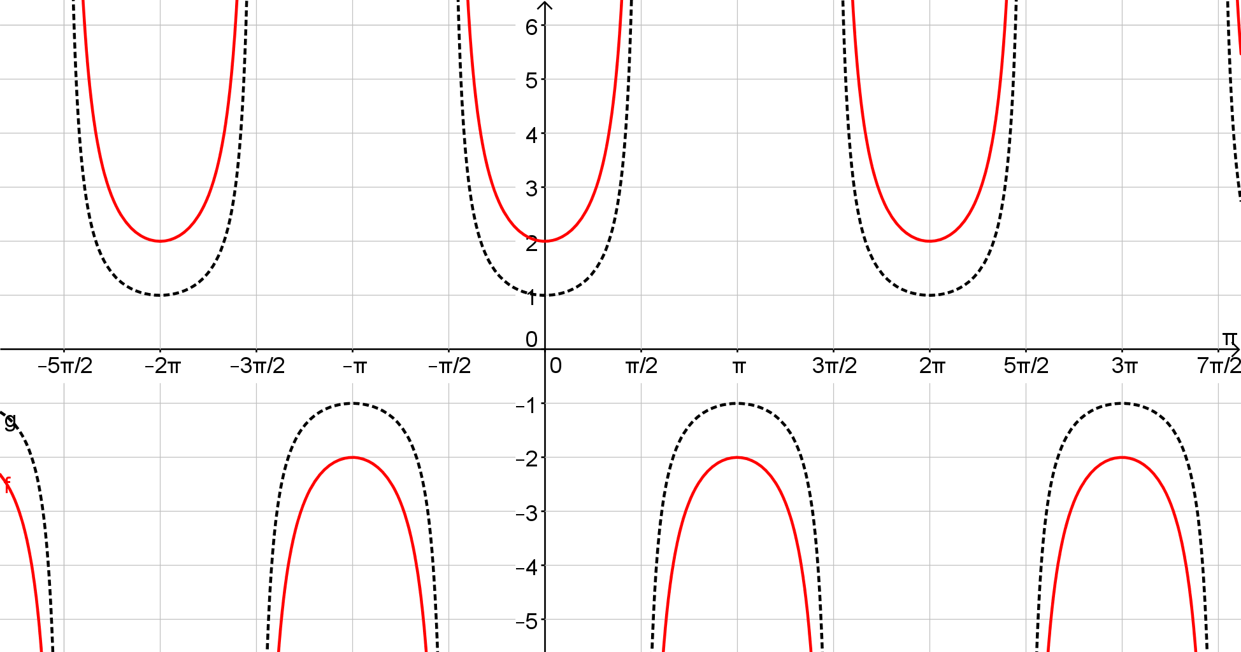

**Continued on the next page**

13. Value of A =      Value of B =       Period =       Equation: *y*=     csc(     *x*) 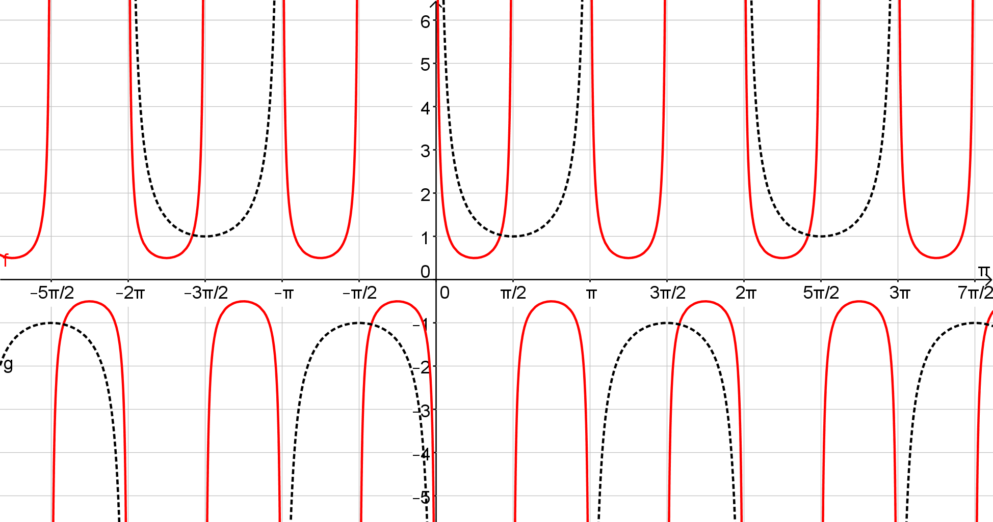

14. Value of A =      Value of B =       Period =       Equation: *y*=     csc(     *x*) 