Name:

Date:

School:

Facilitator:

6.06 Graphs of Logarithms (28 Points)

This task requires you to create a graph. You have several options:

• Use the Word tools;

• Draw the graph by hand, then photograph or scan your graph; or

• Use the GeoGebra linked on the Task page of the lesson to create the graph; then, insert a screenshot of the graph into this task.

**Use the GeoGebra Log Grapher linked on the Task page to answer the following question.**

1. Imagine that you are asked to graph log6(*x* + 3) − 2. How does this graph compare to that of the graph of log6 (*x*)?

**Use the blank grids below to graph the given equations. You are given the parent function. You may draw your graph using the Word tools to sketch the graph. Then, answer the given questions.**

1. *f*(*x*) = log3(*x* – 5) + 2

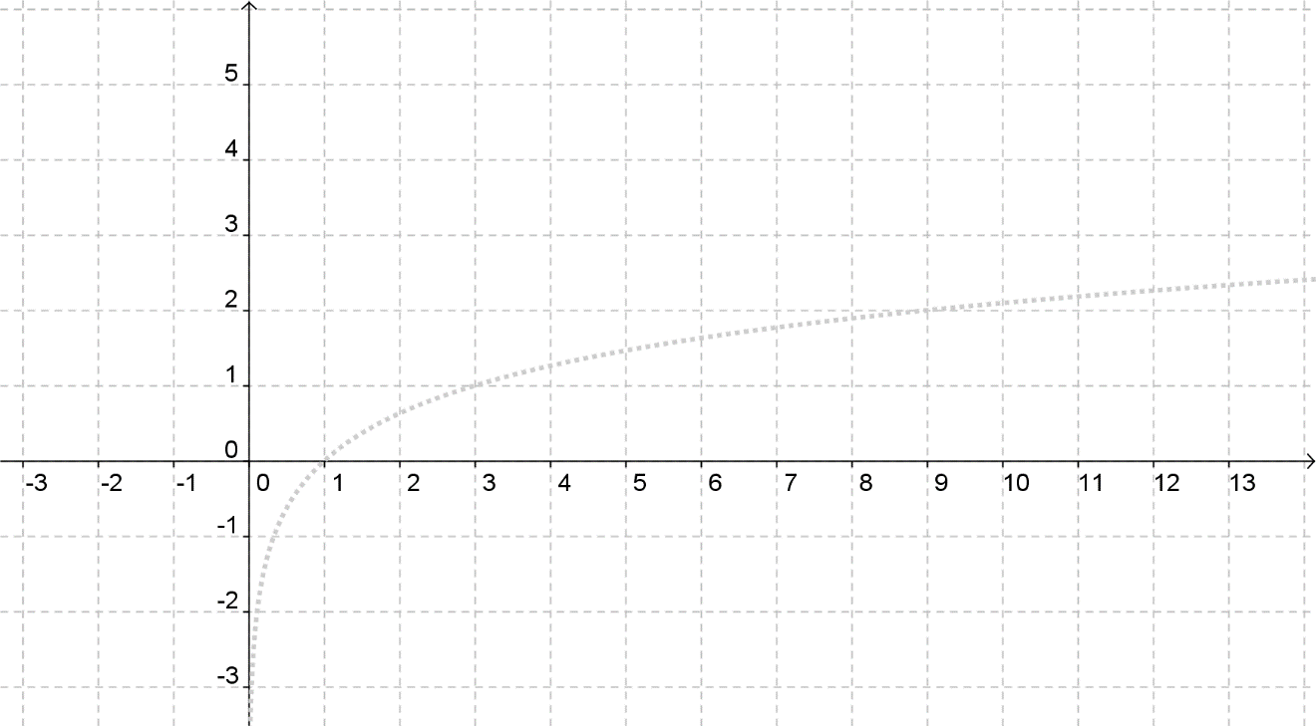

**Domain:**       **Range:**       **Asymptote:**

**x-intercept:**       **y-intercept:**

**End Behavior:** As x approaches       from the left, the graph tends to      and as x approaches      on the right the graph tends to      .

1. *f*(*x*) = log2(*x* + 3) − 1

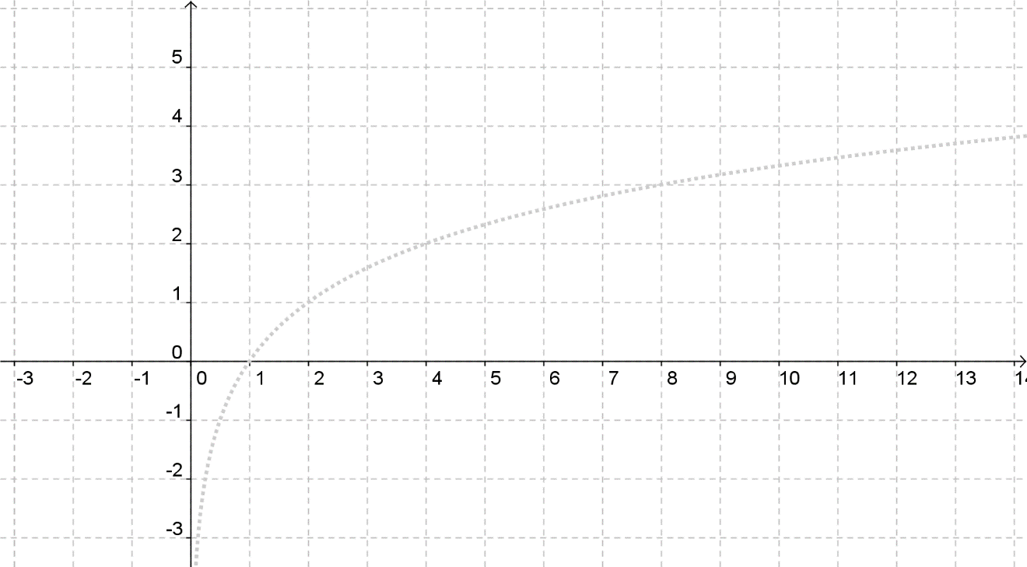

**Domain:**       **Range:**       **Asymptote:**

**x-intercept:**       **y-intercept:**

**End Behavior:** As x approaches       from the left, the graph tends to      and as x approaches      on the right the graph tends to      .

**Use GeoGebra linked on the task page to solve the equations. Go to Edit 🡪 Graphics View to Clipboard to copy and insert your graphic. Then, prove your solution by substituting it back into the equation.**

**Note:** *To graph logs in Geogebra, enter the base and argument in the input as follows:   
logb(x + h) -🡪 log(b, x + h)*

1. log3(*x* + 7) = 3

**Solution:**

**Insert image below:**

**Verify solution:**

1. log2(*x* − 2) = log4(6*x* + 4)

**Solution:**

**Insert image below:**

**Verify solution:**