Name:

Date:

School:

Facilitator:

6.02 Graphing Exponential Functions (33 Points)

**This task requires you to create a graph. You have several options:**

**• Use the Word tools;**

**• Draw the graph by hand, then photograph or scan your graph; or**

**• Use the GeoGebra linked on the Task page of the lesson to create the graph; then, insert a screenshot of the graph into this task.**

Use the given equations to answer the questions. When asked to sketch the curves, you can either draw them on the provided coordinate plane using your tablet OR insert shapes and drag them to the grids to make a draft. Keep in mind that the draft graph does not have to be perfect, but should include a few critical points, show the asymptote, and have the appropriate shape.

1. *f*(*x*) = 4*x* − 5 + 2

a. What is the parent function?

b. What is the base?

c. Is the 5 translation left or right?

d. Is the 2 translation up or down?

e. What is the new asymptote? *y* =

f. What is the x-intercept? *x*:

g. What is the y-intercept? *y*:

h. Name the domain and range.

i. Describe the end behavior:

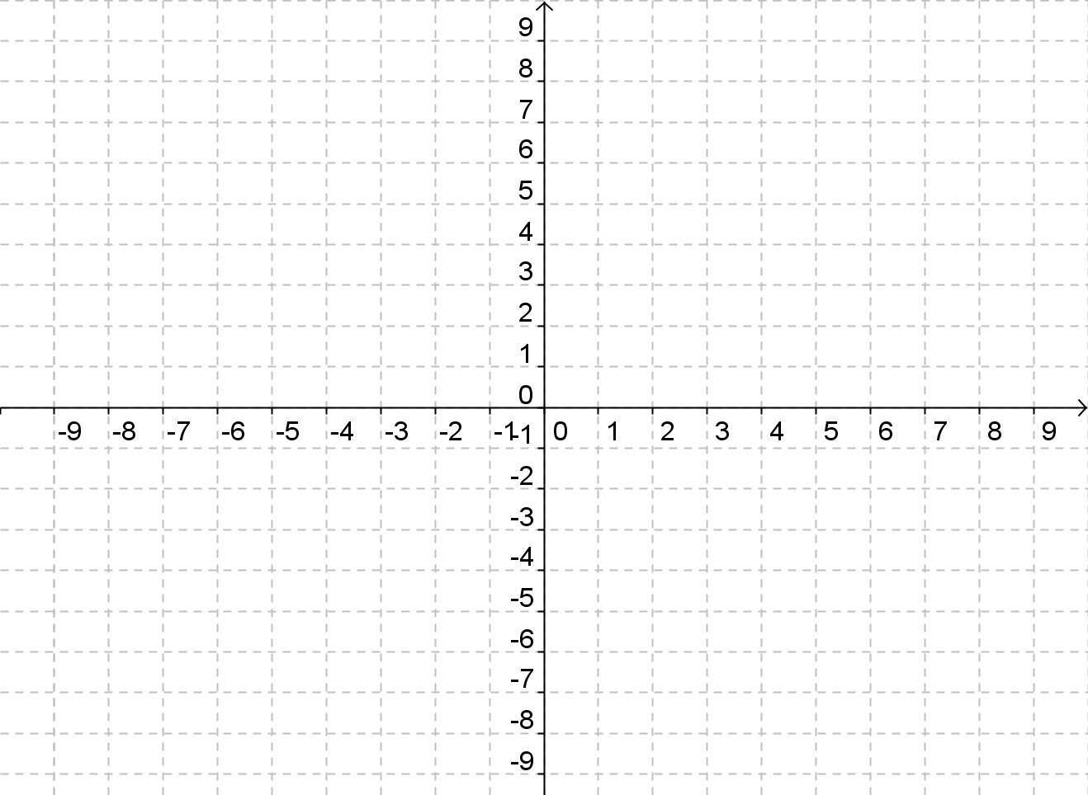

1. Graph for question #1.

2. *f*(*x*) = 3*x* + 2 − 1

a. What is the parent function?

b. What is the base?

c. Is the 2 translation left or right?

d. Is the 1 translation up or down?

e. What is the new asymptote? *y* =

f. What is the x-intercept? *x*:

g. What is the y-intercept? *y*:

h. Name the domain and range.

i. Describe the end behavior:



2. Graph for question #2.

3. *f*(*x*) = 2−(*x* + 3) + 4

a. What is the parent function?

b. What is the base?

c. What does the negative in front of the x do?

d. Is the 3 translation left or right?

e. Is the 4 translation up or down?

f. What is the new asymptote? *y* =

g. What is the x-intercept? *x*:

h. What is the y-intercept? *y*:

i. Name the domain and range.

j. Describe the end behavior:



3. Graph for quesiton #3.

4. *f*(*x*) = −2*x* − 5 − 3

a. What is the parent function?

b. What is the base?

c. What does the negative in front of the 2 do?

d. Is the 5 translation left or right?

e. Is the 3 translation up or down?

f. What is the new asymptote? y =

g. What is the x-intercept? x:

h. What is the y-intercept? y:

i. Name the domain and range.

j. Describe the end behavior:



4. Graph for question #4.

**Use the Geogebra Blank Grid link on the Task page to solve the following problems graphically. Enter your solution and a screenshot of your graph for credit. Remember, enter the equations in the input bar, click on the right move button 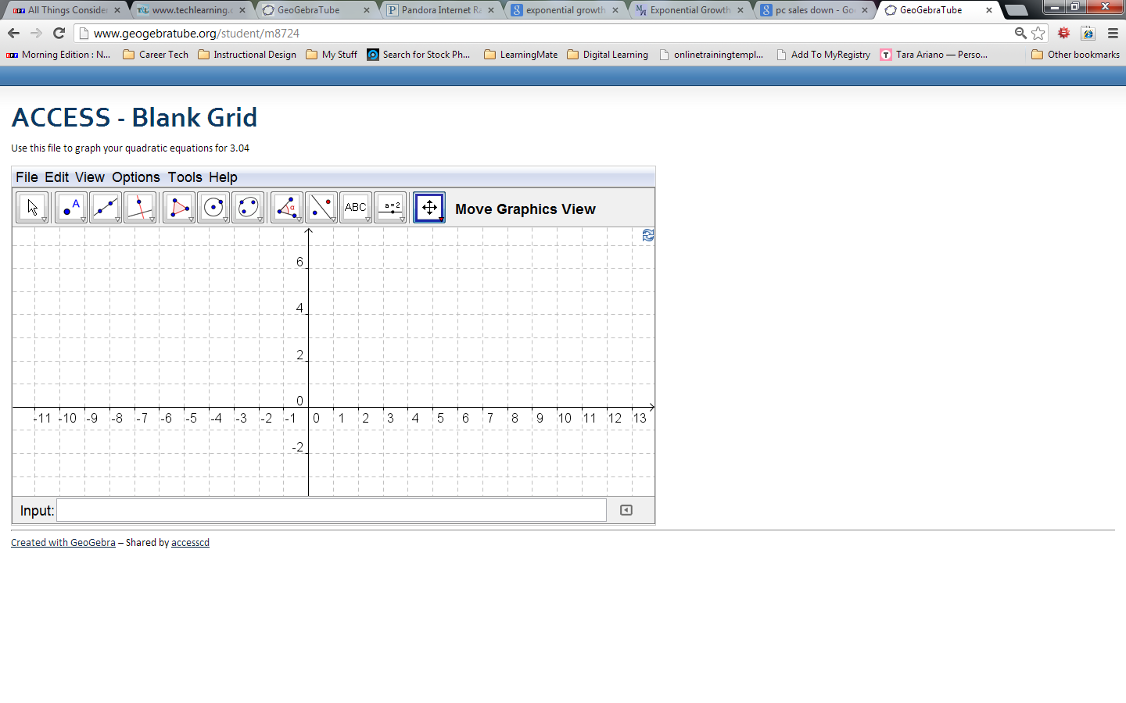to zoom in or zoom out, and choose Edit 🡪 Graphics View to Clipboard to copy your picture and insert it into the assignment.**

5. 2*x* + 3 = 32

*x* =

Insert your graph below:

6. 3*x* + 1 = 9*x* − 1

*x* =

Insert your graph below: