Name:

Date:

School:

Facilitator:

5.05 Odd and Even Functions (35 Points)

**Using each graph below, determine which if the function would be even, odd, or neither.**

1. 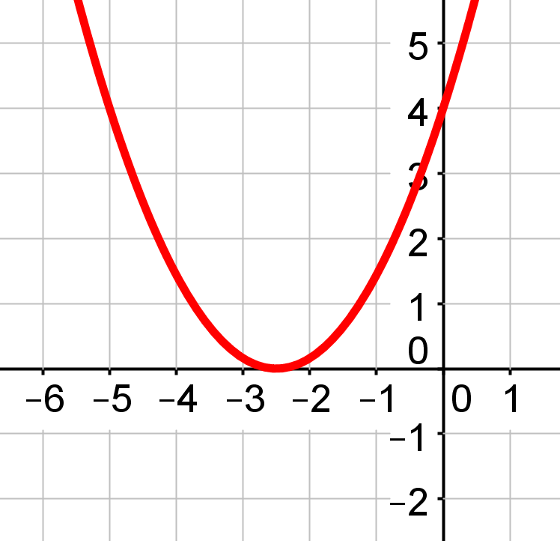

**Even, odd, or neither?**

1. 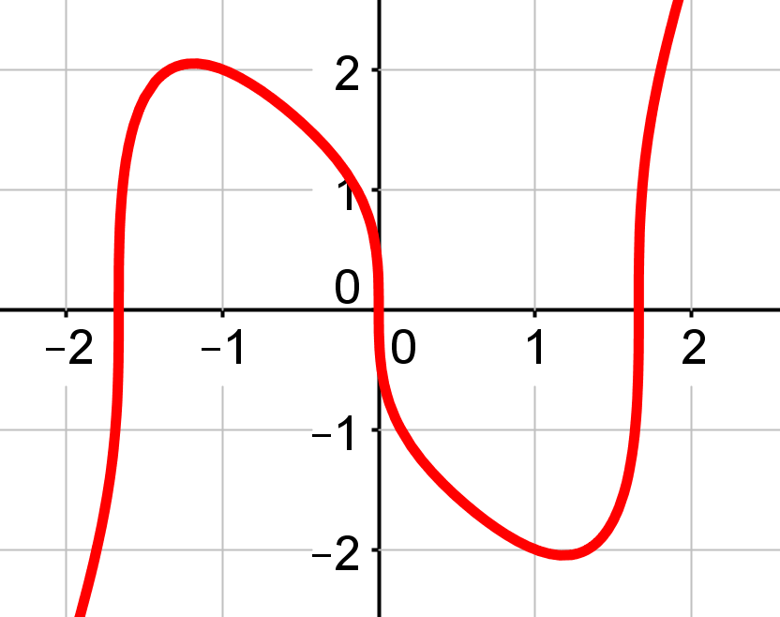

**Even, odd, or neither?**

1. Line chart

   Description automatically generated with low confidence

**Even, odd, or neither?**

1. 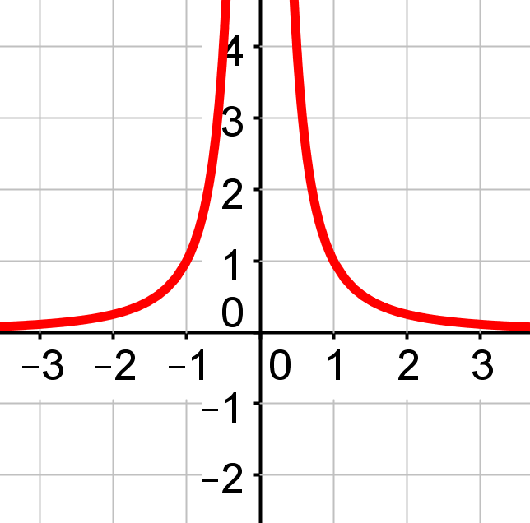

**Even, odd, or neither?**

1. 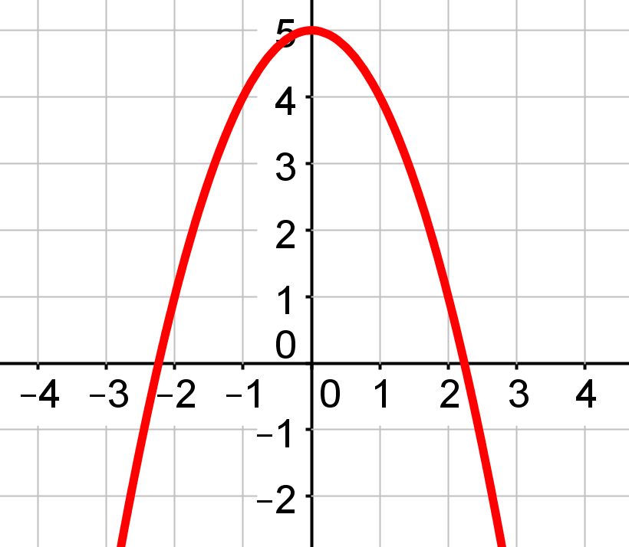

**Even, odd, or neither?**

1. 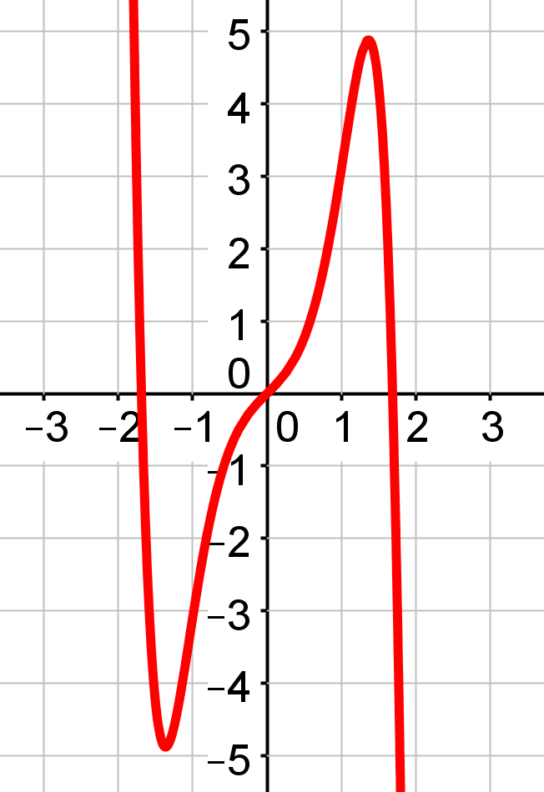

**Even, odd, or neither?**

**Fill in the blanks.**

1. For a function to be      , the graph must be symmetric about the *y*-axis.
2. For a function to be      , a function will have opposite *x*-values, but the same *y*-value.
3. To be considered an odd function, the function must be symmetric about the      .
4. True or false? If a function is neither even nor odd, then −*f*(*x*) = *f*(−2*x*).

**Using the equation of the function, determine if the function is even, odd, or neither. Show all work. If you only state that it is even, odd, or neither, you will not receive full credit.**

1. *f* (*x*) = *x*2 + 16

Even, odd, or neither?

| **Check to see if the function is even:** | **Check to see if the function is odd:** |
| --- | --- |
|  |  |

1. *f* (*x*) = *x*3 + 1

Even, odd, or neither?

| **Check to see if the function is even:** | **Check to see if the function is odd:** |
| --- | --- |
|  |  |

1. *f* (*x*) = -*x*5

Even, odd, or neither?

| **Check to see if the function is even:** | **Check to see if the function is odd:** |
| --- | --- |
|  |  |