Name:

Date:

School:

Facilitator:

5.04 Cube Root Function (46 Points)

This task requires you to create a graph. You have several options:

* Use the Word tools;
* Draw the graph by hand, then photograph or scan your graph; or
* Use the GeoGebra linked on the Task page of the lesson to create the graph; then, insert a screenshot of the graph into this task.

**State the vertex of each function.**

1. *y* = $\sqrt[3]{x+5}$ − 7

Vertex: (     ,     )

1. *y* = −2 $\sqrt[3]{x+2}$

Vertex: (     ,     )

1. *y* = $\sqrt[3]{3x-18}$ − 8

Vertex: (     ,     )

1. *y* = $\sqrt[3]{4x}$ − 5

Vertex: (     ,     )

**Explain how each new graph (in red) was transformed from the parent graph (in gray). Be as specific and detailed as possible. When stating the new vertex, make sure your *b*-value is 1 so you will correctly state the vertex.**

1. *y* = $\sqrt[3]{x+4}$ − 6

New Vertex: (     ,     ) Description:

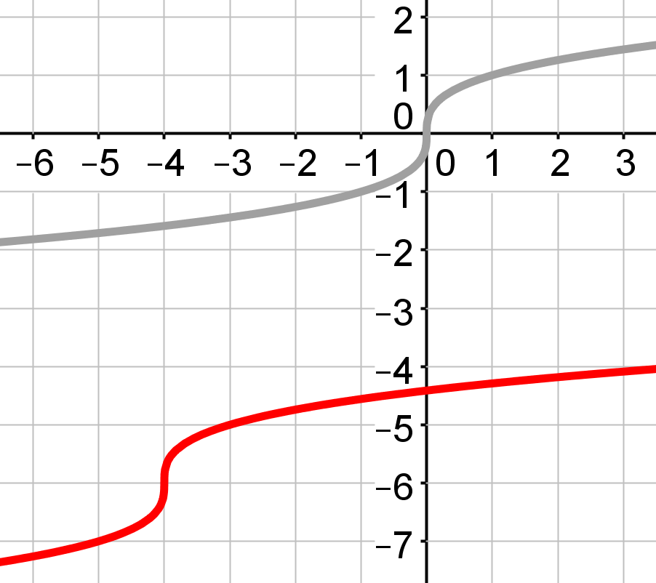

1. *y* =−2 $\sqrt[3]{2x+4}$ − 5

New Vertex: (     ,     ) Description:

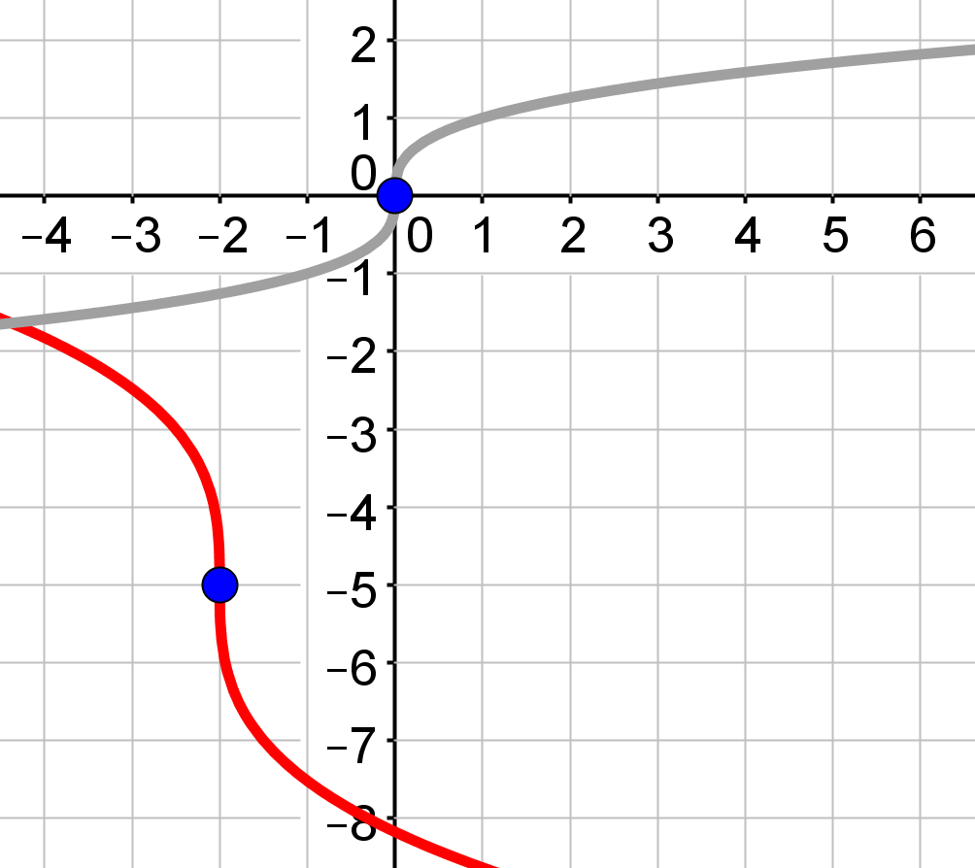

1. *y* =3 $\sqrt[3]{x}$ +4

New Vertex: (     ,     ) Description:

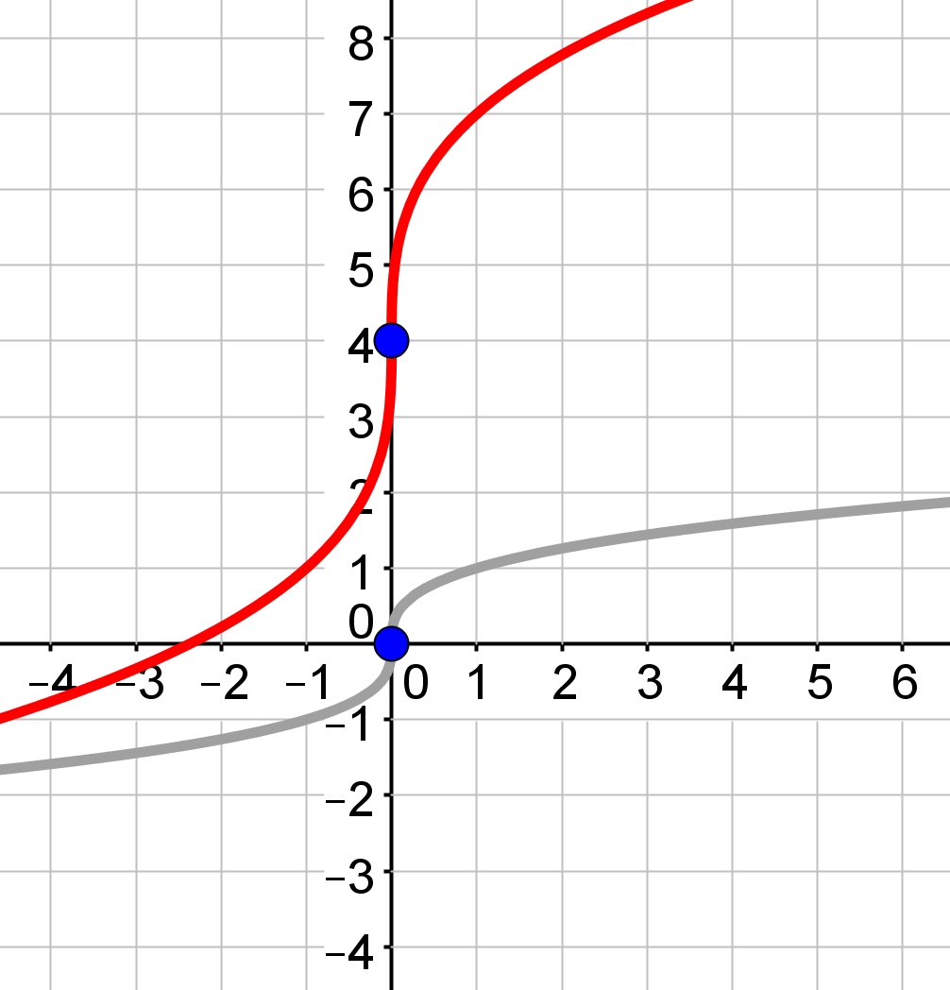

**Complete the *x*-*y* table for each of the following functions. Then, graph the function and tell the vertex, domain and range. 8-9, 10 points each**

1. *y* =− $\sqrt[ 3]{2x+2 }$ − 4

Vertex: (     ,     )

Domain:

Range:

(The vertex goes to the 4th row.)

| **x** | **y** |
| --- | --- |
|  |  |
|  |  |
|  |  |
|  |  |
|  |  |

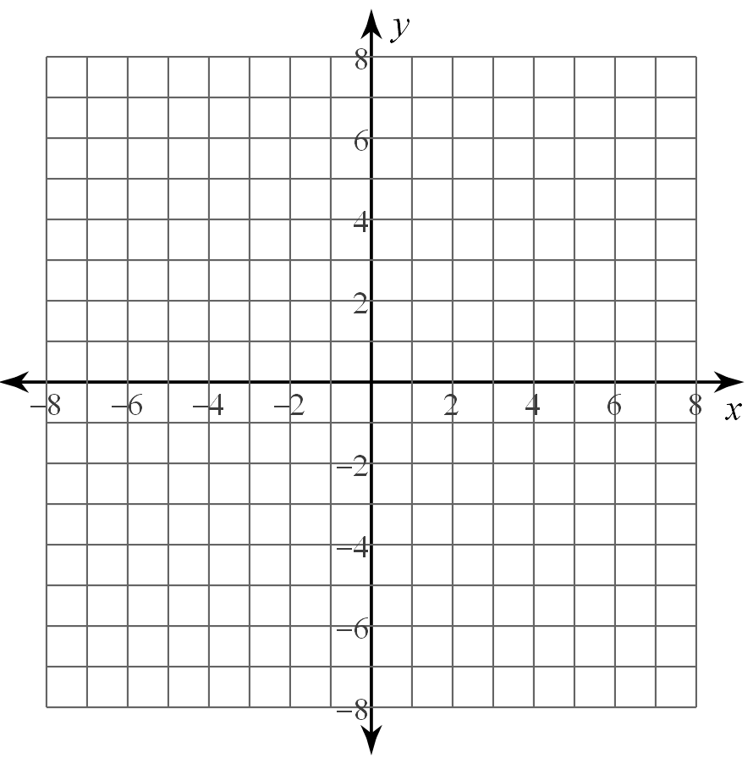

1. *y* =2 $\sqrt[ 3]{x-1 }$ + 3

Vertex: (     ,     )

Domain:

Range:

(The vertex goes to the 4th row.)

| **x** | **y** |
| --- | --- |
|  |  |
|  |  |
|  |  |
|  |  |
|  |  |

