Name:

Date:

School:

Facilitator:

5.03 Translating Radical Functions (48 Points)

**First, name the starting vertex of the parent graph and the translated graphs in the blanks provided. Second, describe the translation for each graph (red) from the parent graph (gray). Remember to include whether the graph was shifted left or right, up or down, if the graph was flipped, or if the graph appears to be stretched or shrunk (you do not have to include the factor of stretching and shrinking).**

1. 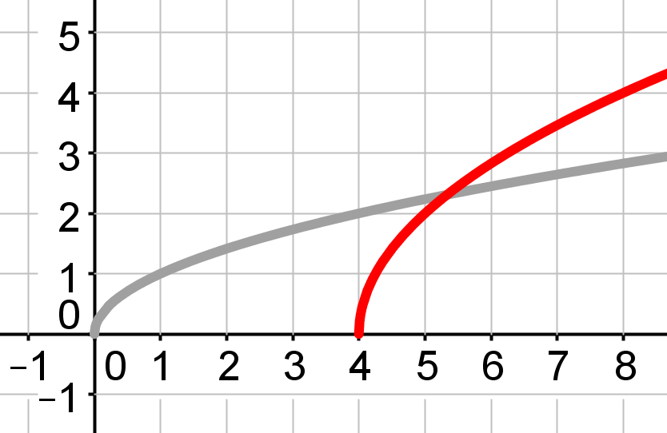

Vertex of Parent Graph: (     ,     ) Vertex of Translated Graph: (     ,     )

Description of Translation:

1. 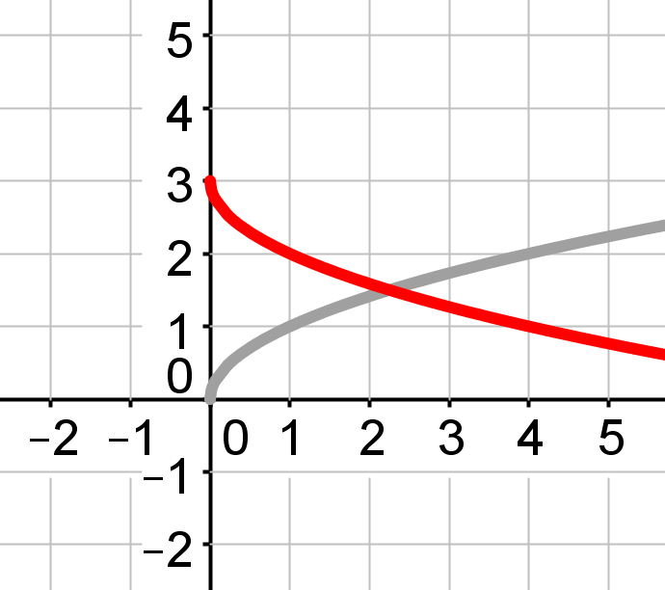

Vertex of Parent Graph: (     ,     ) Vertex of Translated Graph: (     ,     )

Description of Translation:

1. 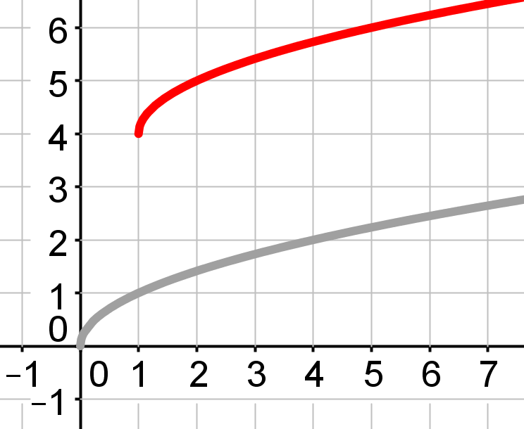

Vertex of Parent Graph: (     ,     ) Vertex of Translated Graph: (     ,     )

Description of Translation:

1. 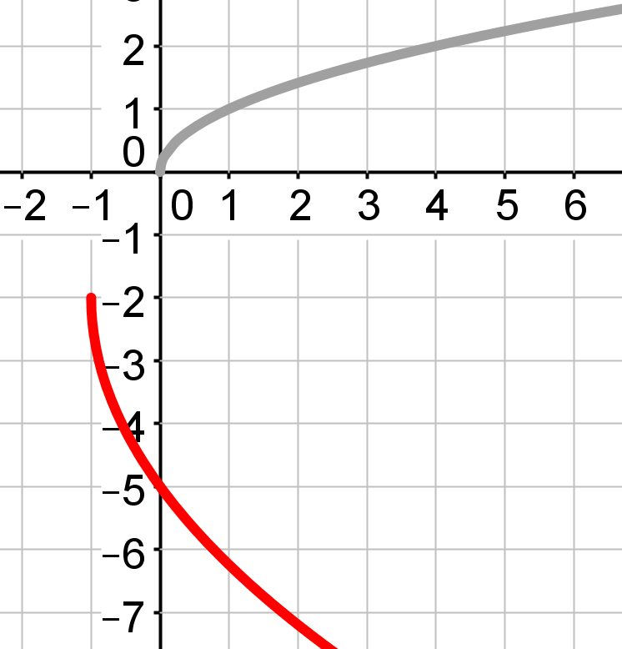

Vertex of Parent Graph: (     ,     ) Vertex of Translated Graph: (     ,     )

Description of Translation:

**Using the provided equations, name the vertex and describe how the equation would be translated from the parent graph** *f* (*x)* = $\sqrt{x}$**. Be as specific as possible with your descriptions.**

1. *f* (*x)* = -3 $\sqrt{x+1 }$-5

Vertex: (     ,     ) Description of Translation:

1. *y* = 0.4 $\sqrt{x-9 }$-8

Vertex: (     ,     ) Description of Translation:

**Complete the *x*-*y* table for each function and match it with the appropriate graph. To being the *x*-*y* table, you will need to find the vertex for the graph. Remember that your vertex is also the first row of your *x*-*y* table. Be sure to provide a description of each translation from the parent graph. Note: not all graphs are used.**

| **Graphs** | **(A)** | **(B)** | **(C)** |
| --- | --- | --- | --- |

| **Graphs** | **(D)** | **(E)** |
| --- | --- | --- |

1. *f* (*x)* = −2 $\sqrt{x-2 }$ +1 Vertex: (     ,     ) Graph: (     )

Complete the *x-y* table here:

| *x* | *y* |
| --- | --- |
|  |  |
|  |  |
|  |  |
|  |  |

Description of the Translation:

1. *y* = $\sqrt{x+2 }$ −1 Vertex: (     ,     ) Graph: (     )

Complete the *x-y* table here:

| *x* | *y* |
| --- | --- |
|  |  |
|  |  |
|  |  |
|  |  |

Description of the Translation:

1. *f* (*x)* = 2 $\sqrt{x-4 }$ +2 Vertex: (     ,     ) Graph: (     )

Complete the *x-y* table here:

| *x* | *y* |
| --- | --- |
|  |  |
|  |  |
|  |  |
|  |  |

Description of the Translation: