Name:
Date:
School:
Facilitator:

5.02 Graphing Radical Functions (43 Points)
For each radical function, determine the domain of the function, complete the x-y table, and match the function with its graph below. Note: Not all graphs will be needed.
Graphs | (A)  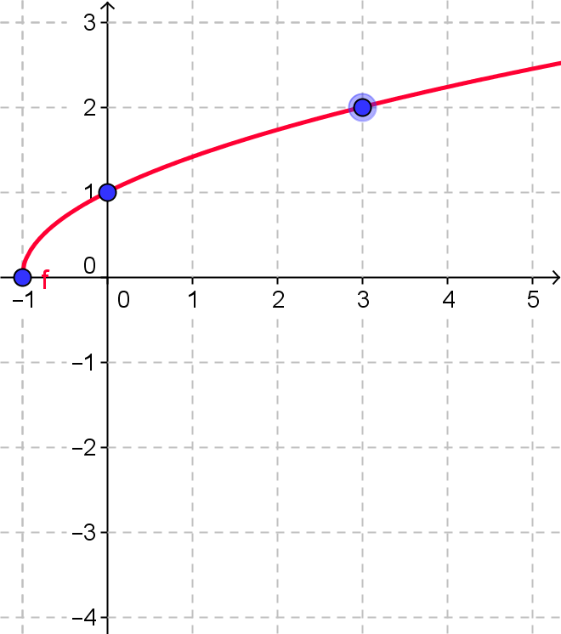 | (B)  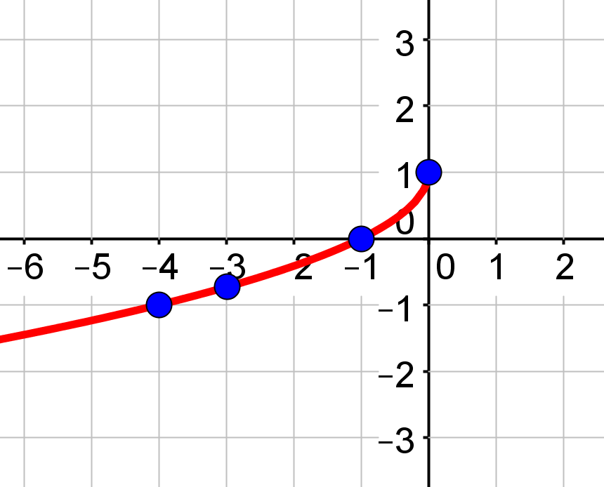 | (C)  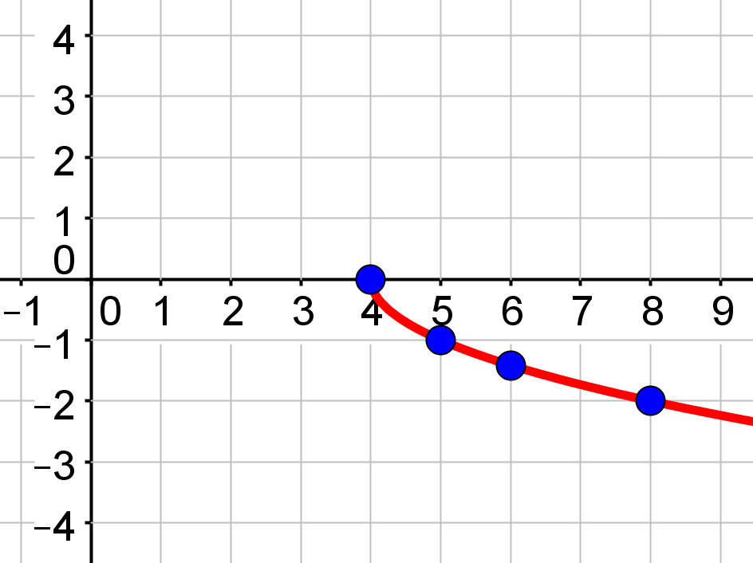

Graphs | (D)  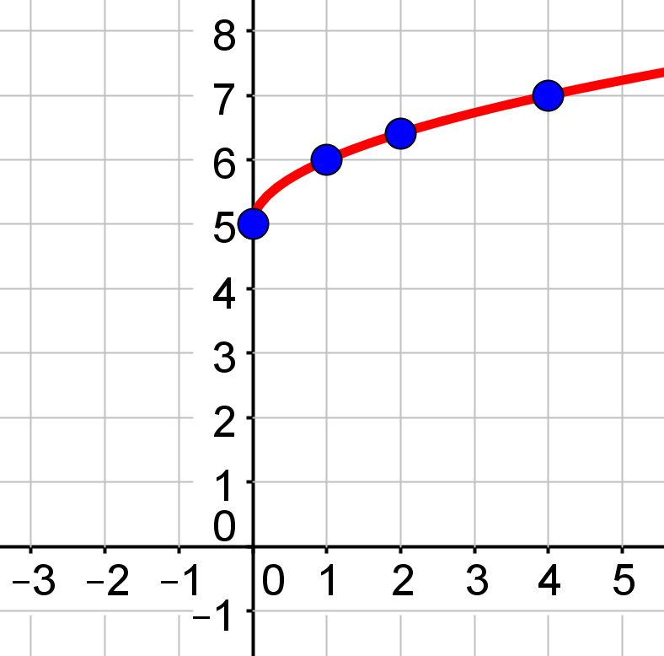 | (E)  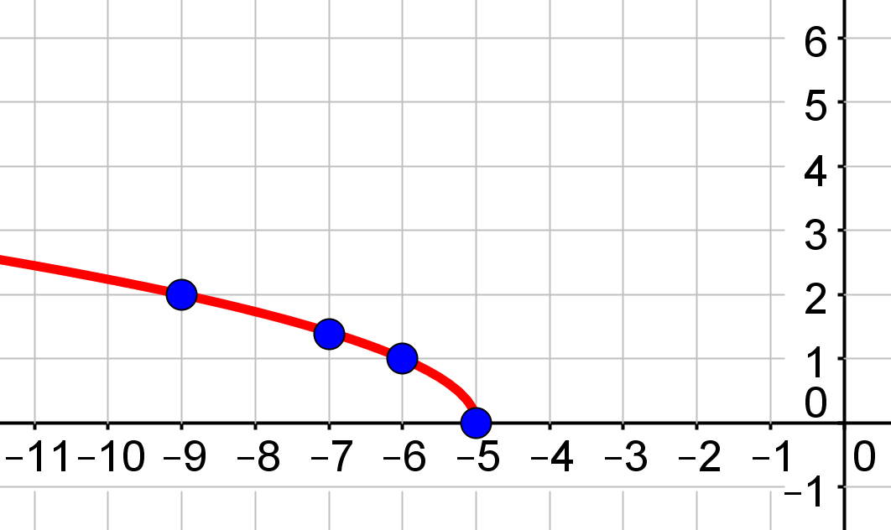 | (F)  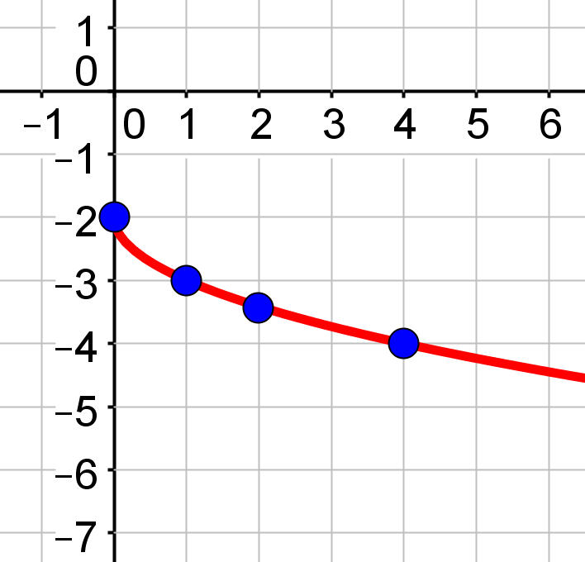

- f (x) = $\sqrt{x+1}$ Domain: Graph:

Show your work for the Domain here:

Complete the x-y table below.
x | y
-1
0
1
3

- y = -$\sqrt{x}$ -2 Domain: Graph:

Show your work for the Domain here:

Complete the x-y table below.
x | y
0
1
2
4

- f (x) = $\sqrt{-x-5}$ Domain: Graph:

Show your work for the Domain here:

Complete the x-y table below.
x | y
-5
-6
-7
-9

- y = -$\sqrt{x-4}$ Domain: Graph:

Show your work for the Domain here:

Complete the x-y table below.
x | y
4
5
6
8

- y = -$\sqrt{-x}$ +1 Domain: Graph:

Show your work for the Domain here:

Complete the x-y table below.
x | y
0
-1
-3
-4

Marianne and John are comparing answers on their math homework. They are confused about one particular problem where they both calculated the domain and found different answers. Their work is shown below.

The function they are graphing is f (x) = $\sqrt{-3x-12}$
Marianne’s work for the Domain:
−3x – 12 ≥ 0
−3x ≥ 12
x ≥ −4

John’s work for the Domain:
−3x – 12 ≥ 0
−3x ≥ −12
x ≤ 4

- Whose work is correct, Marianne’s, John’s or neither? Explain how the student calculated it incorrectly, if both students are incorrect; explain how both calculated the domain incorrectly.
- Correctly work the problem showing each step.
Show your work here:

