Name:

Date:

School:

Facilitator:

4.07 Graphing and Approximating (62 Points)

This task requires you to create a graph. You have several options:

* Use the Word tools;
* Draw the graph by hand, then photograph or scan your graph; or
* Use the GeoGebra linked on the Task page of the lesson to create the graph; then, insert a screenshot of the graph into this task.

**Complete all parts of each problem below. Do not just complete the graphs**.

1. Suppose the factors of a polynomial are (*x* – 1)(*x* + 2)²(*x* – 4). Sketch a rough graph of the polynomial.

**Step 1:** Find the x intercepts. Set each factor equal to zero and solve

*x*=, *x*=, *x*=

**Step 2:** Mark each x-intercept on the x-axis of a coordinate plane. Do not number the y-axis. Draw the points using the Shapes tool below to mark the x intercepts.

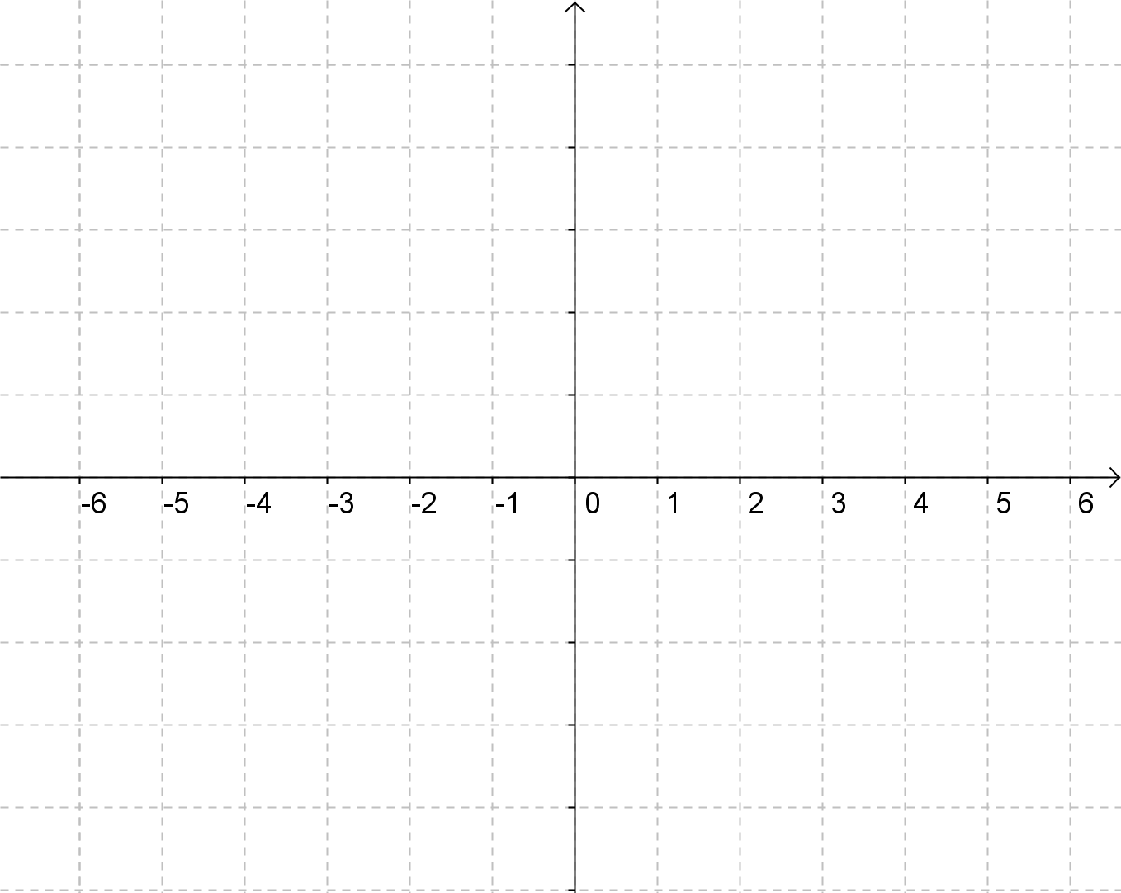

**Step 3:** Find the relative maximum and/or the relative minimum between each x intercept.

* Halfway between the first two points:
* Evaluate the polynomial at this point: .
* Halfway between the second two points:
* Evaluate the polynomial at this point: .

**Step 4:** Sketch a rough graph. Use the Shapes tool to draw the approximate curve. Draw the points as needed using the Shapes tool and label them. Label the scale of the y axis.



y=

y=

y=

y=

y=

y=

1. Sketch a rough graph of the polynomial *P*(*x*) = 2*x*³ + 7*x*² - 9

**Step 1:** Write all of the factors of the first and last term

Factors of 2: ±, ±

Factors of -9: ±, ±, ±

**Step 2:** Write all of the possible rational roots by making fractions where the numerator is a factor of the last term from the polynomial and the denominator is a factor of the first term of the polynomial.

$±\frac{p}{q}=$ ±, ±, ±, ±, ±, ±

**Step 3:** List $P(±\frac{p}{q})$ in order from smallest to largest.

P(     )

P(     )

P(     )

P(     )

P(     )

P(     )

P(     )

P(     )

P(     )

P(     )

P(     )

P(     )

**Step 4:** Evaluate all:

P(     ) =

P(     ) =

P(     ) =

P(     ) =

P(     ) =

P(     ) =

P(     ) =

P(     ) =

P(     ) =

P(     ) =

P(     ) =

P(     ) =

**Step 5:** Choose the x-intercepts and plot on a coordinate plane. Do not number the y-axis. Draw the points using the Shapes tool below to mark the x intercepts.



**Step 6:** Find the relative maximum and/or the relative minimum between each x intercept.

* Halfway between the first two points:
* Evaluate the polynomial at this point: .
* Halfway between the second two points:
* Evaluate the polynomial at this point: .

**Step 7:** Sketch a rough graph. Use the Shapes tool to draw the approximate curve. Draw the points as needed using the Shapes tool and label them. Label the scale of the y axis.



y=

y=

y=

y=

y=

y=

1. Sketch a rough graph of the polynomial *P*(*x*) = *x*³ + 6*x*² + 11*x* + 6

*Step 1:* Write all of the factors of the first and last term

Factors of 1: ±

Factors of 6: ±, ±, ±, ±

*Step 2:* Write all of the possible rational roots by making fractions where the numerator is a factor of the last term from the polynomial and the denominator is a factor of the first term of the polynomial.

$±\frac{p}{q}=$ ±, ±, ±, ±

*Step 3:* List $P(±\frac{p}{q})$ in order from smallest to largest.

P()

P()

P()

P()

P()

P()

P()

P()

*Step 4:* Evaluate all.

P() =

P() =

P() =

P() =

P() =

P() =

P() =

P() =

**Step 5:** Choose the x-intercepts and plot on a coordinate plane. Do not number the y-axis. Draw the points using the Shapes tool below to mark the x intercepts.



**Step 6:** Find the relative maximum and/or the relative minimum between each x intercept.

* Halfway between the first two points:
* Evaluate the polynomial at this point: .
* Halfway between the second two points:
* Evaluate the polynomial at this point: .

**Step 7:** Sketch a rough graph. Use the Shapes tool to draw the approximate curve Draw the points as needed using the Shapes tool and label them. Label the scale of the y axis.



y=

y=

y=

y=

y=

y=

1. Graph the polynomial $P\left(x\right)=3x^{5}-6x^{2}+2x+1$ using a graphing utility and approximate the roots.

The approximate roots are: {, , }

Graph: Insert a screenshot