Name:
Date:
School:
Facilitator:

3.08 Applications of Quadratic Functions
A rocket is launched from the ground and the path of the rocket is modeled by the equation h = −4t² – 80t where h represents the height of the rocket (in feet) after t seconds. Using the graph, answer each question.

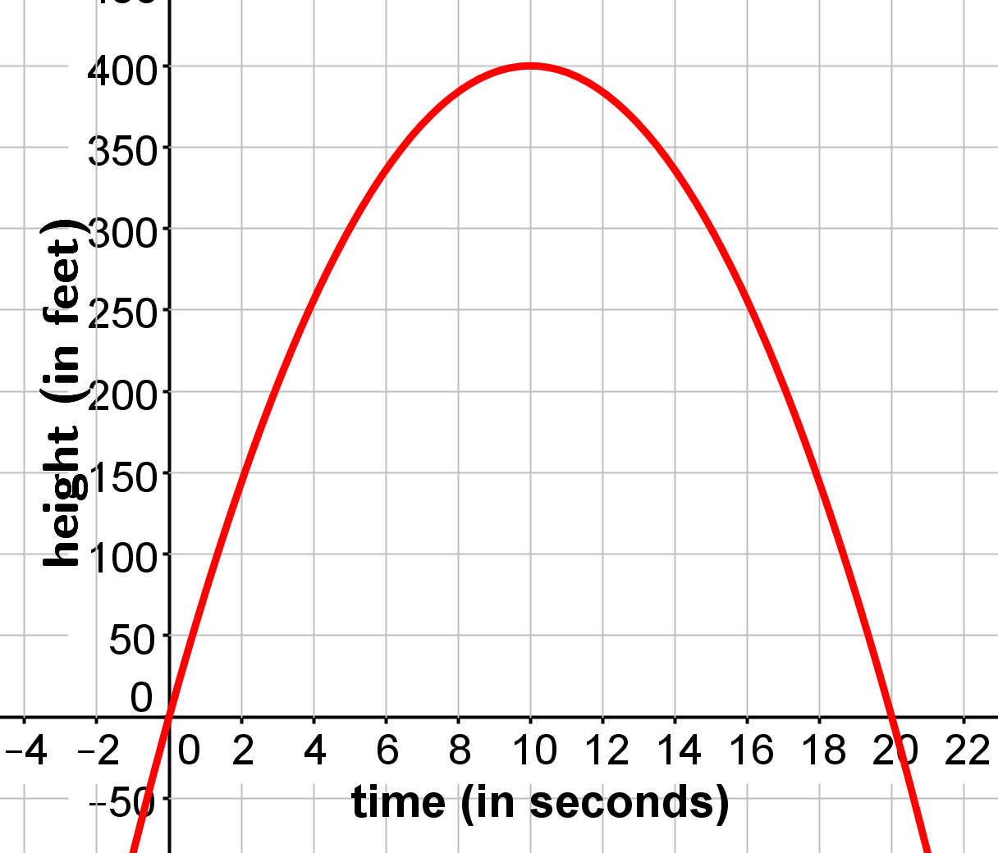

- How long does it take for the rocket to reach the ground? Be sure to include your units.

- How did you determine your answer for #1?

- What is the maximum height the rocket will reach?

- How did you determine the maximum height in #3? Be specific.

- How many seconds will it take for the rocket to reach its maximum height?

- How did you determine how long it would take for the rocket to reach its maximum height in #5? Be specific.

A rocket carrying fireworks is launched from a hill above a lake. The rocket will fall into the lake after exploding at its maximum height. The rocket’s height above the surface of the lake is given by the function h = −16t² + 64t + 80. In this function, h is the height of the rocket (in feet) and t is the amount of time (in seconds). Use this information to answer each question.

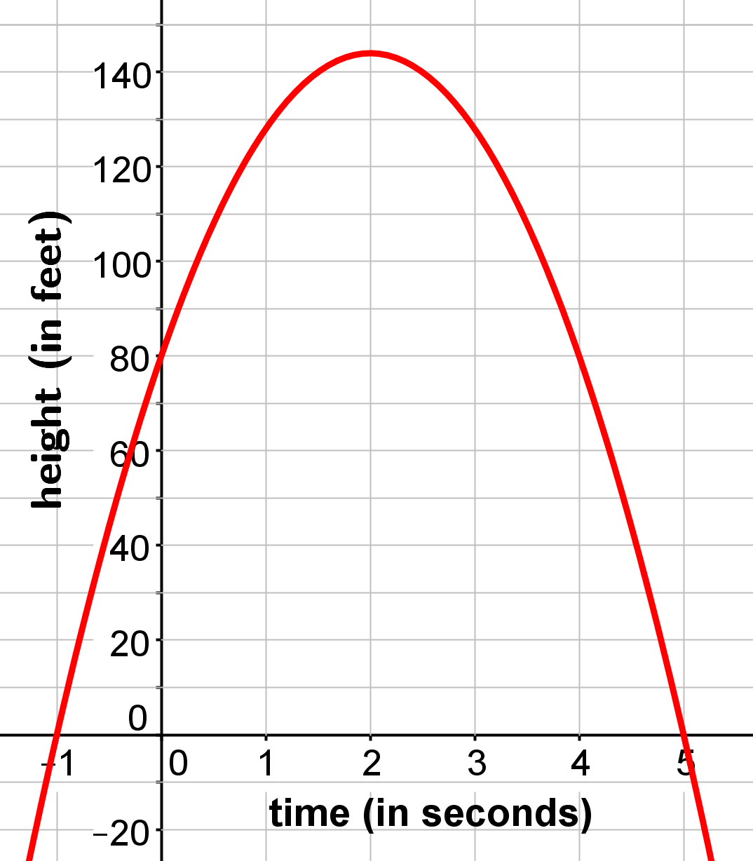

- Determine the domain and range of this function as it applies to the situation.
- Domain:

- Range:

- Determine the maximum height of the rocket. Be sure to show each step of your work including simplification below your answer.
Answer: the rocket will reach its maximum height of feet after seconds.

- Using the quadratic formula, determine how long it will take for the rocket to reach the ground. Be sure to show each step of your work including simplification.

Show your work using the quadratic formula in the space below.
x = seconds and x = seconds
One of solutions is not realistic answer. Which answer is not possible and why?

The answer x = is not a possible answer because .
Final answer:
The rocket will reach the ground after seconds.
- Predict the height of the rocket after 3 seconds. Show your work below.

Farmer Joe wants to fence in a rectangular area that has one side bordered by a stream. If he has 80 meters of fencing, what are the dimensions and the maximum area he can enclose? The area of the fenced area can be found using the formula A = lw where l represents the length and w represents the width.

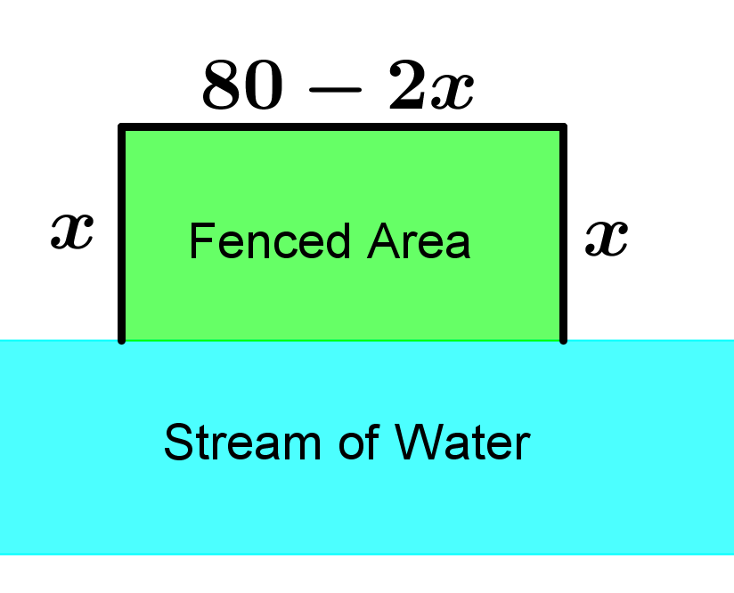

- Substitute in the formula and simplify to find the function to find the maximum area. Show your work below.

- Find the value of x which is the value of the width. Be sure to show each step of your work including simplification.

- Substitute into 80 − 2x and simplify to find the value of the length. Show your work below.

- Substitute x = 20 into the function A = 80x – 2x² to find the maximum area. Show your work below.

The conclusion is that the dimensions of the fenced area will be meters by meters and the maximum area of the fenced region is square meters.

