Name:

Date:

School:

Facilitator:

3.07 Vertex Form of Quadratic Functions (52 Points)

**For each function, identify the vertex, domain, range, and axis of symmetry. Answer yes or no to whether there is a vertical stretch, vertical compression, or reflection over the x-axis. Then, choose the correct graph for each function from the choices below. You will not use all of the graphs.**

|  |  |  |
| --- | --- | --- |
| (A)  A coordinate plane with a parabola opening up with a vertex at (negative 3, negative 4) that passes through points (negative 4, negative 2) and (negative 2, negative 2). | (B)  A coordinate plane with a parabola opening up with a vertex at (negative 2, negative 2) that passes through points (negative 3, 1) and (negative 1, 1). | (C) |
| (D) | (E) | (F) |

|  |  |  |
| --- | --- | --- |
| (G) | (H) | (I) |

|  |  |  |  |  |
| --- | --- | --- | --- | --- |
| 1. | *y* = -(*x* + 4)2 – 4 | | |  |
|  | Vertex: (     ,     )  Domain:  Range: | Axis of Symmetry: *x* =  Vertical stretch:  Vertical compression: | | Graph:  Reflection over the x-axis: |
|  | **Show work for the second point here:** | | Second Point: (     ,     ) | |
|  |  | | | |

|  |  |  |  |  |
| --- | --- | --- | --- | --- |
| 2. | *y* = 3(*x* – 1)2 | | |  |
|  | Vertex: (     ,     )  Domain:  Range: | Axis of Symmetry: *x* =  Vertical stretch:  Vertical compression: | | Graph:  Reflection over the x-axis: |
|  | **Show work for the second point here:** | | Second Point: (     ,     ) | |
|  |  | | | |

|  |  |  |  |  |
| --- | --- | --- | --- | --- |
| 3. | *f*(*x*) = 2(*x* + 3)2 – 4 | | |  |
|  | Vertex: (     ,     )  Domain:  Range: | Axis of Symmetry: *x* =  Vertical stretch:  Vertical compression: | | Graph:  Reflection over the x-axis: |
|  | **Show work for the second point here:** | | Second Point: (     ,     ) | |
|  |  | | | |

|  |  |
| --- | --- |
|  |  |

|  |  |  |  |  |
| --- | --- | --- | --- | --- |
| 4. | *f*(*x*) = -(*x* – 1)2 + 4 | | |  |
|  | Vertex: (     ,     )  Domain:  Range: | Axis of Symmetry: *x* =  Vertical stretch:  Vertical compression: | | Graph:  Reflection over the x-axis: |
|  | **Show work for the second point here:** | | Second Point: (     ,     ) | |
|  |  | | | |

|  |  |  |  |
| --- | --- | --- | --- |
| **Write the quadratic equation in vertex form. Identify the vertex, domain, range, and axis of symmetry. Answer yes or no to whether there is a vertical stretch, vertical compression, or reflection over the x-axis. Then, graph the function.**   |  |  | | --- | --- | | 5. *f*(*x*) = 2*x*2 – 4x –1  Vertex Form: **y =**       **(x**            **)2**        **Show work here writing the equation in vertex form:**  Vertex:      Axis of Symmetry:      Reflection over the x-axis:  Domain:      Vertical Stretch:  Range:      Vertical Compression:  **Show work for the second point here:** Second Point:  Graph (see below):    Empty graph with x and y axis. Graph size displayed from -5 to 5 on the x axis and -5 to 5 on the y axis.  axis of symmetry  axis of symmetry  Vertex  2nd Point |  | |  |

6. Write the equation of the quadratic function shown in vertex form.

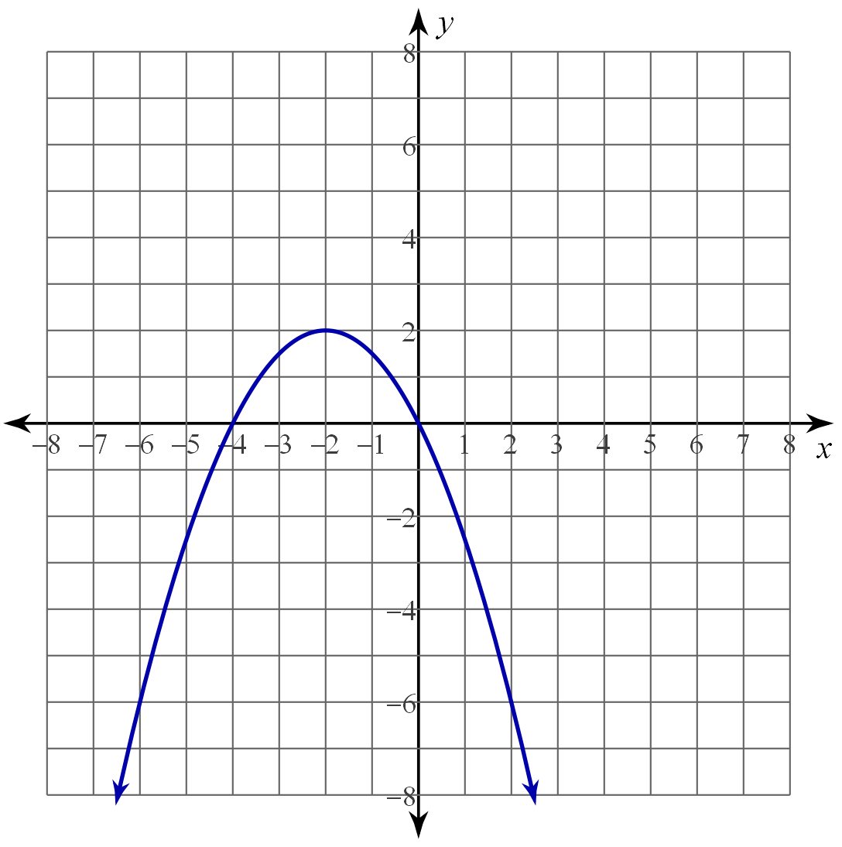

Equation: **y = (x            )2**

**Show work here:**

**Vertex (**     **,**      **) Other Point (**     **,**      **)**

     **= a (**               **)2**      

     **= a (**      **)2**      

     **=**      **a**      

     **=**      **a**

**= a**

7. Use geogebra to find the solutions to the following system of equations.

y = -3(x -2)2 + 5

y = 2x – 4

Solutions: x =       ,

Insert a picture of the graph below:

8. Compare the graph of f(x) = x2 + 4x + 6 shown below with a parabola with an *a* value of -2 and a vertex

of ( 3, 2).

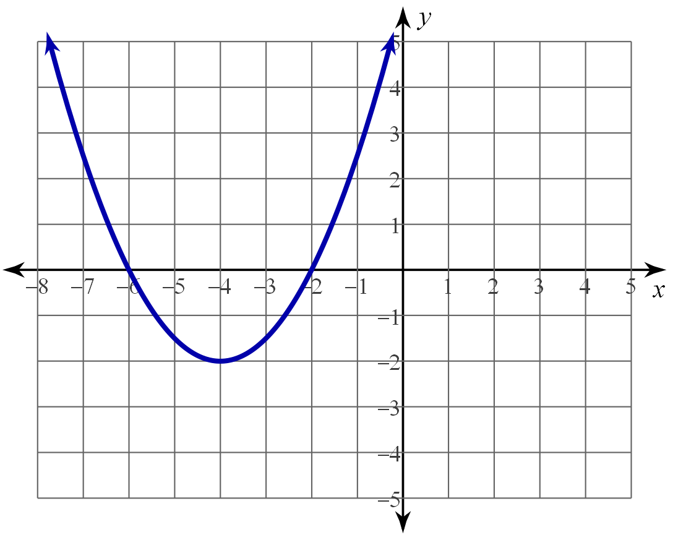

|  |
| --- |
| *Write your response below:* |
|  |