Name:
Date:
School:
Facilitator:

3.06 Focus on Quadratics (46 Points)
This task requires you to create a graph. You have several options:
- Use the Word tools;
- Draw the graph by hand, then photograph or scan your graph; or
- Use the GeoGebra linked on the Task page of the lesson to create the graph; then, insert a screenshot of the graph into this task.
- Find the axis of symmetry for y = 4x² + 16x - 2.
- x = 2
- x = −2
- x = 8
- x = −8

- Find the axis of symmetry for y = −x² − 9x + 4.
- x = −$\frac{2}{9}$
- x = −18
- x = $\frac{9}{2}$
- x = − $\frac{9}{2}$

- Find the vertex of y = 3x² + 12x + 2.
- (2,38)
- (−2, −10)
- (−2, −34)
- (2, 36)

- Find the vertex of y = −2x² − 3x − 1.
- $\left(-\frac{3}{4},\frac{1}{8}\right)$
- $\left(\frac{3}{4}, 1\right)$
- $\left(-3, -10\right)$
- $\left(3, -28\right)$

- Find the x-intercept(s) of y = x² − 5x − 14.
- (14,0)
- (−7,0) and (2,0)
- (−14,0)
- (7,0) and (-2,0)

- Find the x-intercept(s) of y = 3x² + 10x − 8.
- $\left(\frac{2}{3}, 0\right)$ and $\left(4, 0\right)$
- $\left(-8, 0\right)$
- $\left(\frac{2}{3}, 0\right)$ and $\left(-4, 0\right)$
- $\left(8, 0\right)$

- Find the y-intercept(s) of y = x² − 5x − 14.
- (0, 14)
- (-7,0) and (2,0)
- (0, -14)
- (7,0) and (-2,0)

- Find the y-intercept(s) of y = 3x² − 10x − 24.
- $\left(\frac{2}{3}, 0\right)$ and $\left(4, 0\right)$
- $\left(0, -24\right)$
- $\left(\frac{2}{3}, 0\right)$ and $\left(-4, 0\right)$
- $\left(0, -8\right)$

- For the equation y = 2x² − 5x + 2 find the following:
- the values of a,b and c: a = , b = , c =

- the vertex: ( , )

- the x-intercept(s): ( , ) and ( , )

- the y-intercept(s): ( , )

- the axis of symmetry:

- the graph

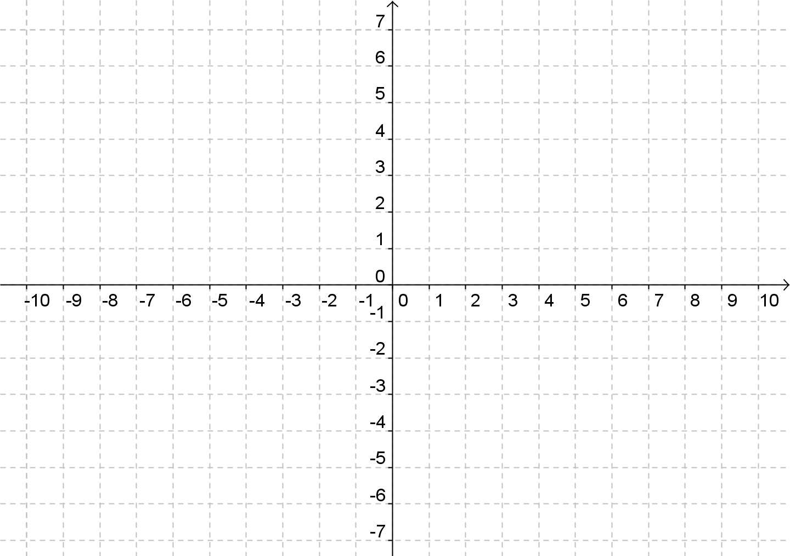
axis of symmetry
x-intercept
vertex
y-intercept
x-intercept
- For the equation y= -x²+7x-12 find the following:
a. the values of a,b and c: a = , b = , c =
b. the vertex: ( , )
c. the x-intercept(s): ( , ) and ( , )
d. the y-intercept(s): ( , )
e. the axis of symmetry:
f. the graph:
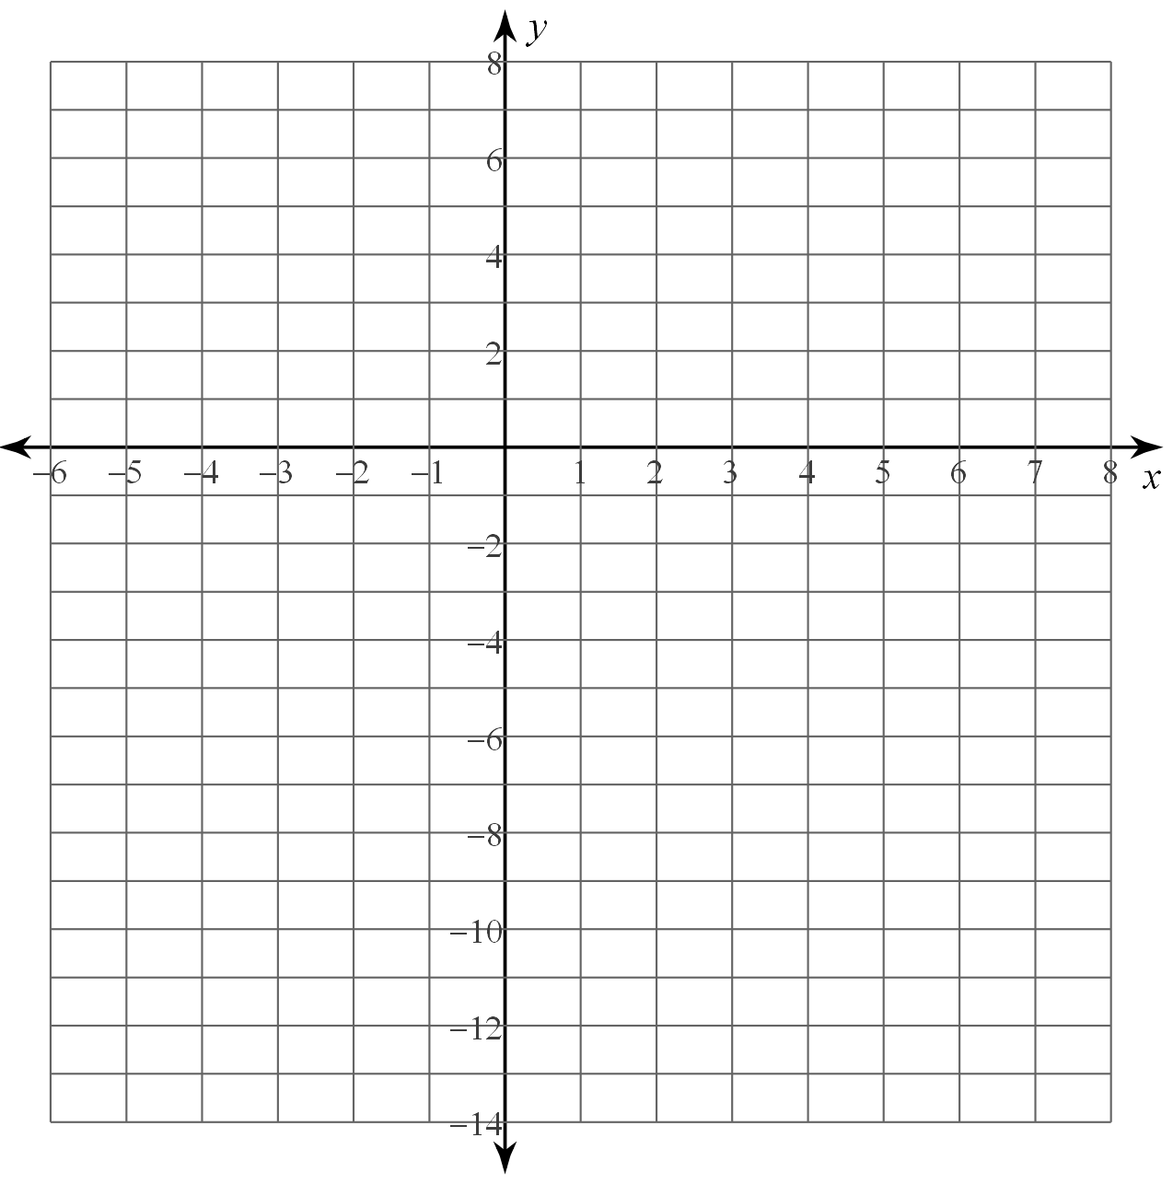
vertex
x-intercept
axis of symmetry
x-intercept
y-intercept

