2.05 Introduction to Matrices Additional Practice

**Solve the problems below. Then, compare your answers and work to 2.05 Introduction to Matrices Additional Practice Key.**

# ****Guided Practice****

1. Perform the indicated operation.

negative 9 times the 2 by 3 matrix Row-: 1Column-,- 1 two-thirds Column-,- 2 0 Column-,- 3 negative 2 Row-: 2Column-,- 1 one-third Column-,- 2 negative 4 over 9 Column-,- 3 one-ninth

# ****Multiple Choice****

**Solve the following matrices by choosing correct answers.**

1. 2 $\left[3\right]$
   1. [5]
   2. [7]
   3. [4]
   4. **\*[6]**

**2[3] = [2 × 3] = [6]**

1. 1 $\left[\begin{matrix}3 & 2\end{matrix}\right]$
   1. **\*1 $\left[\begin{matrix}3 & 2\end{matrix}\right]$**
   2. 9 $\left[\begin{matrix}2 & 8\end{matrix}\right]$
   3. 3 $\left[\begin{matrix}4 & 8\end{matrix}\right]$
   4. 5 $\left[\begin{matrix}3 & 4\end{matrix}\right]$
2. 2[3 4]
   1. **\*[6 8]**
   2. [5 2]
   3. [9 20]
   4. [5 3]

**2 $\left[\begin{matrix}3 & 4\end{matrix}\right]$ = $\left[\begin{matrix}2 ×3 & 2 ×4\end{matrix}\right]$ = $\left[\begin{matrix}6 & 8\end{matrix}\right]$**

1. 2[0]
   1. [6]
   2. [7]
   3. **\*[0]**
   4. [5]

**2[0] = = [0]**

1. 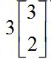
   1. **\*the 2 by 1 column matrix 9 6**
   2. the 2 by 1 column matrix 9 5
   3. the 2 by 1 column matrix 8 4
   4. the 2 by 1 column matrix 5 9

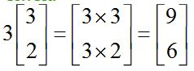

1. 1 times the 2 by 1 column matrix 0 4
   1. 3 times the 2 by 1 column matrix 9 6
   2. **\*1 times the 2 by 1 column matrix 0 4**
   3. 2 times the 2 by 1 column matrix 8 6
   4. 3 times the 2 by 1 column matrix 2 8
2. 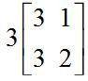
   1. **\*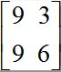**
   2. 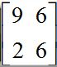
   3. 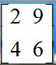
   4. 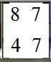

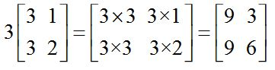

**Use scalar multiplication to solve the following matrices.**

1. 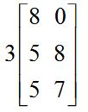
   1. **\*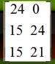**
   2. 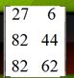
   3. 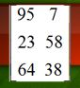
   4. 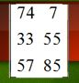

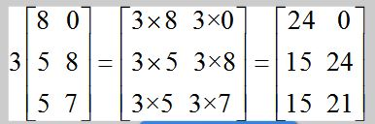

1. 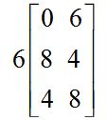
   1. **\*the 3 by 2 matrix Row-: 1 0 36 Row-: 2 48 24 Row-: 3 24 48**
   2. the 3 by 2 matrix Row-: 1 9 24 Row-: 2 39 74 Row-: 3 78 68
   3. the 3 by 2 matrix Row-: 1 8 95 Row-: 2 52 78 Row-: 3 63 38
   4. the 3 by 2 matrix Row-: 1 8 72 Row-: 2 38 83 Row-: 3 29 97

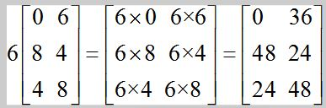

1. 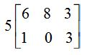
   1. the 2 by 3 matrix Row-: 1 66 54 57 Row-: 2 4 9 36
   2. 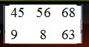
   3. 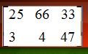
   4. **\*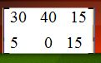**

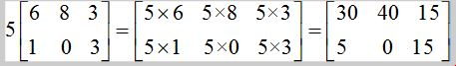

1. 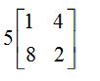
   1. **\*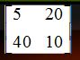**
   2. the 2 by 2 matrix Row-: 1 6 26 Row-: 2 77 34
   3. 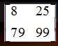
   4. 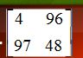

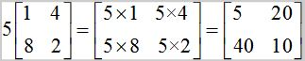

1. 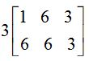
   1. the 2 by 3 matrix Row-: 1 3 79 7 Row-: 2 34 34 3
   2. **\*the 2 by 3 matrix Row-: 1 3 18 9 Row-: 2 18 18 9**
   3. 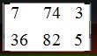
   4. the 2 by 3 matrix Row-: 1 5 88 5 Row-: 2 23 75 8

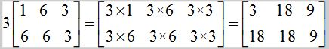

1. 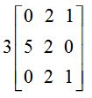
   1. 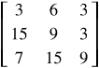
   2. **\*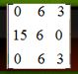**
   3. 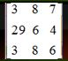
   4. 