Name:
Date:
School:
Facilitator:

1.06 Step Functions (33 Points)

Step Functions
This task requires you to create a graph. You have several options:
- Use the word tools;
- Draw the graph by hand, then photograph or scan your graph; or
- Use the GeoGebra linked on the Task page of the lesson to create the graph, then insert a screenshot of the graph into this task.

You are mailing a package and the post office has the following sign posted which tells you their pricing. Use the chart to answer questions 1-3.

Cost | Weight (in lbs)
$6.00 | 0 < weight ≤ 5
$8.00 | 5 < weight ≤ 8
$10.00 | 8 < weight ≤ 12
$15.00 | 12 < weight ≤ 20

- How much would it cost to mail a package weighing 13 lbs.?
$

- How much would it cost to mail a package weighing 3 lbs.?
$

- How much would it cost to mail a package weighing 12 lbs.?
$

- Graph the following equations with the given constraints. Drag the lines and points as appropriate. You may not use all of the points provided.
f (x) = $\left\{\begin{aligned}2x+3, -3≤x≤0 \\ 3, 0<x≤2 \\ 4x-5, 2<x≤5\end{aligned}\right.$
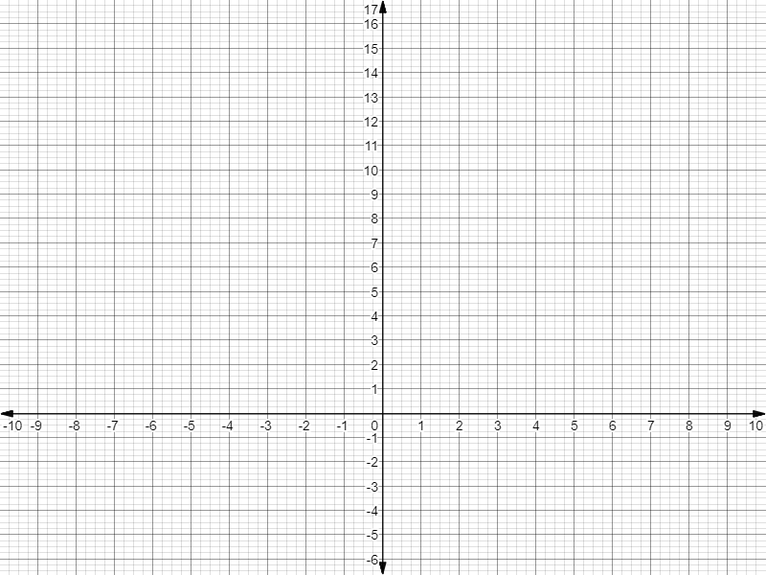

- Graph the following equations with the given constraints.
f (x) = $\left\{\begin{aligned}1, -5≤x<-1 \\ 2, -1≤x<3 \\ 3 3≤x<7\end{aligned}\right.$
