Name:

Date:

School:

Facilitator:

1.05 Linear Equations and Inequalities (38 Points)

# Linear Equations and Inequalities

This task requires you to create a graph. You have several options:

* Use the word tools;
* Draw the graph by hand, then photograph or scan your graph; or
* Use the GeoGebra linked on the Task page of the lesson to create the graph, then insert a screenshot of the graph into this task.

**Drag the lines to the graph and adjust the ends as necessary. If you have a tablet, you can draw directly on the coordinate plane.**

1. Graph: *y* = 2*x* – 4

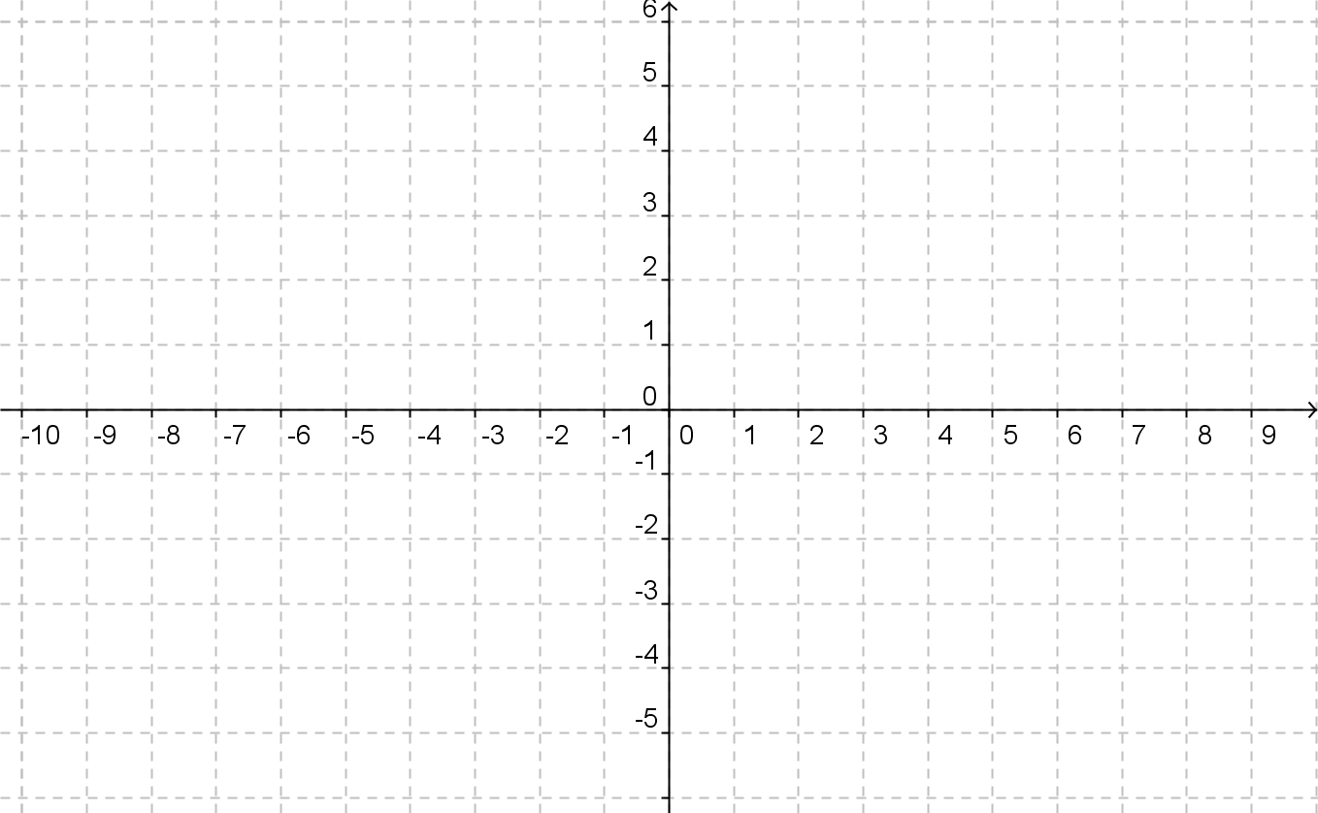

1. Graph: $y=\frac{1}{3 }x-2$



1. Graph: 3*x* - 5*y* = 15



1. Graph: 2*x* – *y* = 4



**Drag the lines to the graph and adjust the ends as necessary. If you have a tablet, you can draw directly on the coordinate plane. The extra lines should be used to indicate the shaded side of the graph.**

1. Graph: *y* < 3*x* – 4



1. Graph: *y* ≥ −*x* + 4



1. Graph: $y<-\frac{3}{4 }x+2$

