1.05 Graphing Linear Functions and Inequalities Additional Practice Key

**Solve the problems below. Then, compare your answers and work to the 1.05 Graphing Linear Functions and Inequalities Additional Practice Key.**

# ****Practice Problems****

**Enter your answer in the space.**

1. Graph 4*x* − 3*y* = 6

First, get the equation in slope intercept form. Move the *x* term to the right side.

**−3*y*** = **−4*x*** + 6

The *y* term should have a coefficient of 1.Divide both sides by −3 to get this coefficient.

*y* = $\frac{-4}{-3}x+\frac{6}{-3}$

Simplify

y = $\frac{4}{3}x-2$

Identify the y-intercept.

The y-intercept is **−2**

Plot the y-intercept.

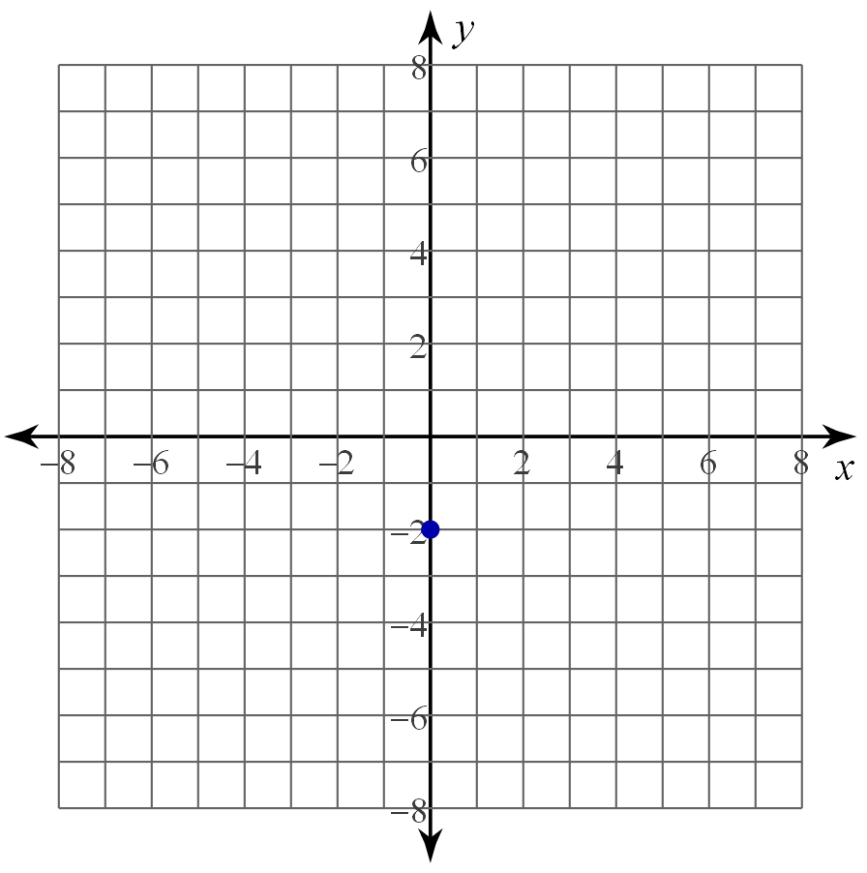

Next, identify the slope.

The slope is $\frac{4}{3}$

Use the slope to plot a point to the left and right of the y-intercept. Remember that slope is rise over run. Then draw a line through your points.

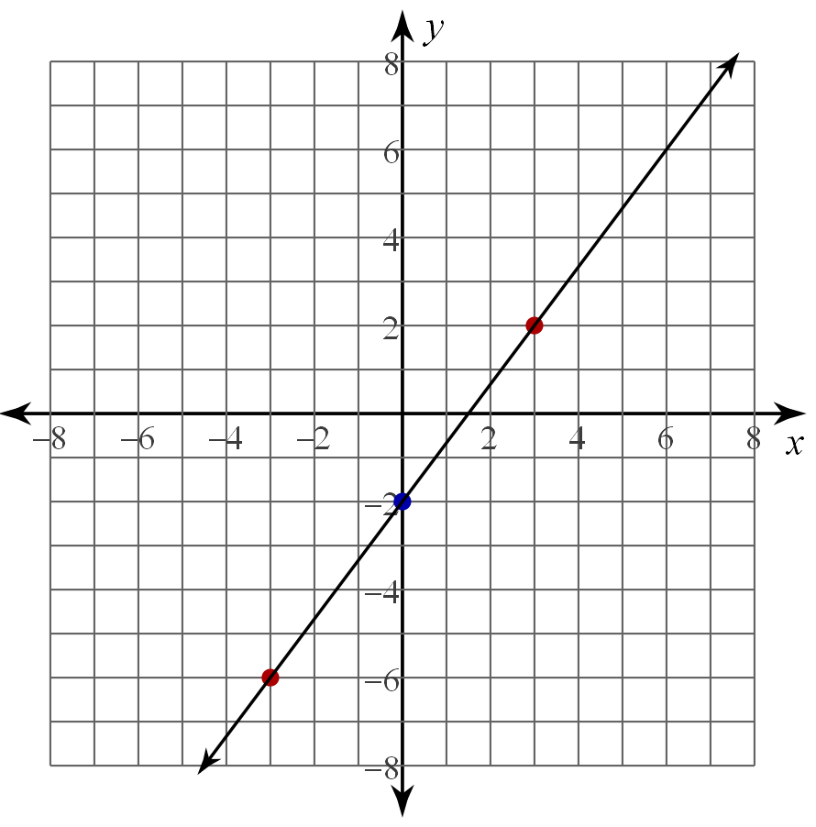

1. Graph $2x-y > 3$

Will the line be dashed or solid? **Dashed**

Get the equation in slope intercept form. Move the x term to the right side.

**−*y*** > **−2*x*** + 3

The *y* term should have a coefficient of 1. Divide both sides by −1 to get this coefficient. We must flip the inequality sign since we are dividing by a negative number.

*y* < $\frac{-2}{-1}x+\frac{3}{-1}$

Simplify

*y* < 2*x* − 3

Identify the *y*-intercept.

The *y*-intercept is **−3**

Plot the *y*-intercept.

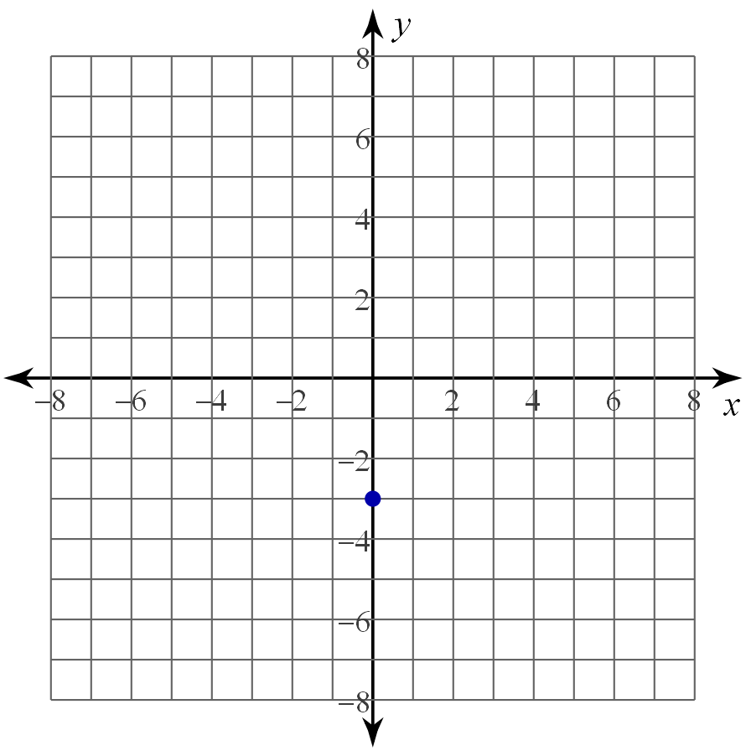

Next, identify the slope. Write it as a fraction.

The slope is **2**

Use the slope to plot a point to the left and right of the *y*-intercept. Remember that slope is rise over run. Draw a dashed line between the points.

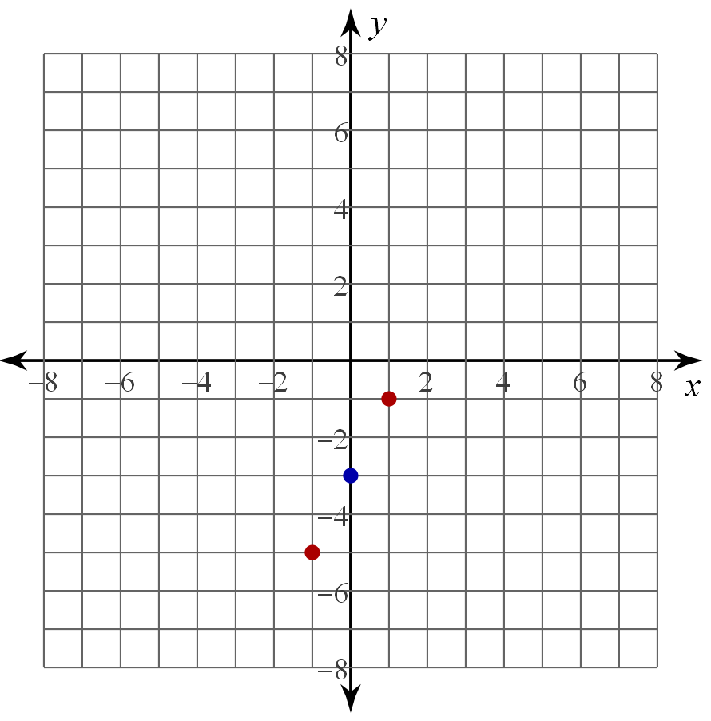

Next, choose a point to test for shading. We can test (0,0). Plug 0 in for *x* and *y* into the original equation.

2*x* − *y* > 3

2(0) − 2(0) > 3

Simplify

0 − 0 > 3

0 > 3

Is 0 greater than 3? No

Shade on the opposite side of the line from the point (0,0).

