1.05 Graphing Linear Functions and Inequalities Additional Practice Key

**Solve the problems below. Then, compare your answers and work to the 1.05 Graphing Linear Functions and Inequalities Additional Practice Key.**

# ****Practice Problems****

**Drag the lines to the graph and adjust the ends as necessary. If you have a tablet, you can draw directly on the coordinate plane.**

1. Graph 4*x* − 3*y* = 6

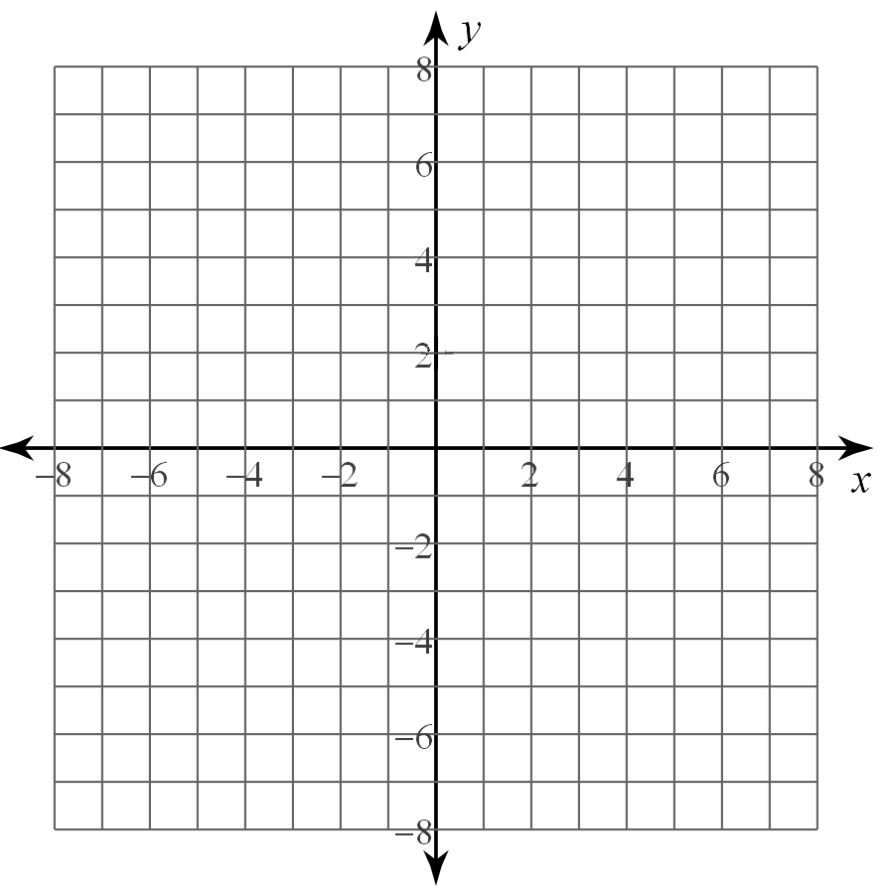

**Drag the lines to the graph and adjust the ends as necessary. If you have a tablet, you can draw directly on the coordinate plane. The extra lines should be used to indicate the shaded side of the graph.**

1. Graph $2x-y > 3$

