Name:
Date:
School:
Facilitator:

4.01 Table of Values
Total Points: 32

This task requires you to create a graph. You have several options:
- Draw the graph by hand, then photograph or scan your graph;
- Use the Microsoft Word or Google Docs drawing tools to graph your data; or
- Use the GeoGebra linked on the Task page of the lesson to create the graph; then, insert a screenshot of the graph into this task.

Make a table of values for each equation with at least 3 domain values. Then, graph the equation using the points from the table of values.
1. y = −3x + 1
X | Y

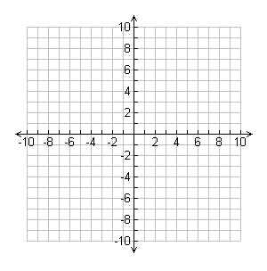
2. y = x + 4
X | Y

3. y = 4x
X | Y

For problems 4 and 5, match the equation to the correct graph. List the letter of the graph that matches.
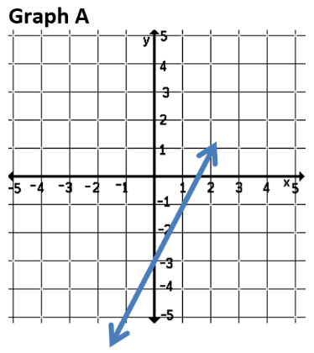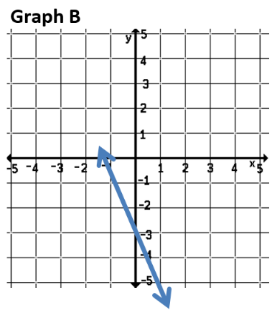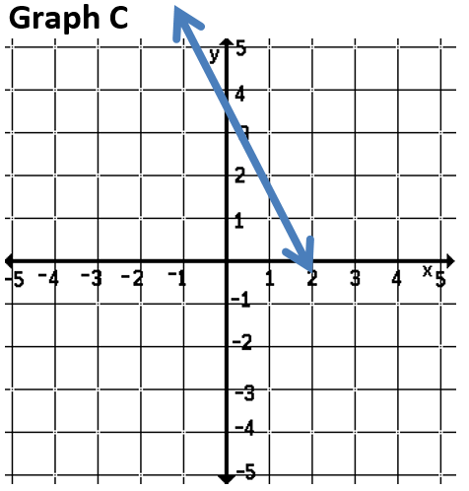

4. y = −2x + 3

5. y = 2x – 3

Answer the following questions using the scenario below. Write your answers as an ordered pair, (hours, $). Show your work for full credit.
Suppose you hire an electrician to install several electrical outlets in your home. The electrician charges $68.00 for materials plus $40.00 per hour for labor.
6. How much will the electrician charge you if the job takes 2 hours?

7. How much will the electrician charge you if the job takes 5 hours?

For problems 8, 9, and 10, determine if the given ordered pair is a solution to the given linear equation. Show you work.
8. Order pair: (2, 1)
Equation: 4x + 3y = 11
Yes or No?
Show work here:

9. Order pair: (5, 10)
Equation: y = 3x – 5
Yes or No?
Show work here:

10. Order pair: (1, 3)
Equation: 2x – 4y = 5
Yes or No?
Show work here:

