Name:
Date:
School:
Facilitator:

3.03 Types of Functions
Total Points: 20
Examine all 10 graphs. For each, identify the function represented as:
- linear,
- quadratic,
- exponential,
- piecewise,
- step,
- absolute value, or
- polynomial.
If the graph is not a function, write “Not a function”.
1. | 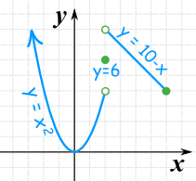
2. | 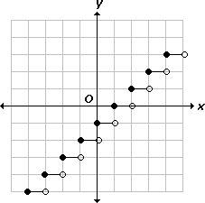
3. | 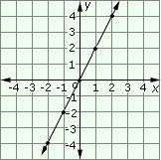
4. | 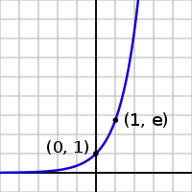
5. | 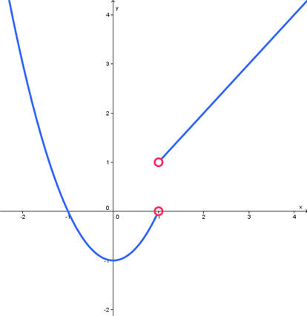
6. | 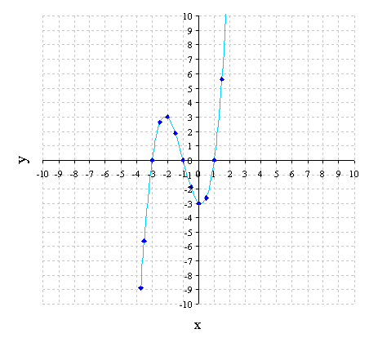
7. | 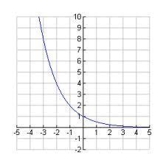
8. | 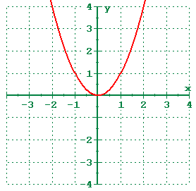
9. | 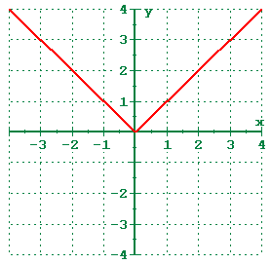
10. | 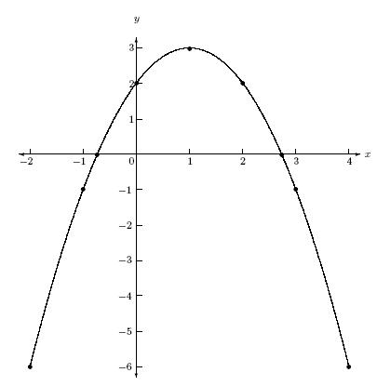

For #11-14, state what type of function each basic equation represents (linear, quadratic, exponential, piecewise, step, absolute value, or polynomial).

- $f(x) = x^{2}$
Type of function:

- $f(x) = b^{x} , where b is any positive number not equal to 1.$
Type of function:

- $f\left(x\right)=|x|$
Type of function:

- $f(x) = x$
Type of function:

For #15-20, state what type of function each equation represents (linear, quadratic, exponential, piecewise, step, absolute value, or polynomial).

- $f(x) = 2x + 3$
Type of function:

- $f(x) = 2|x| + 5$
Type of function:

- $f(x) = {3x}^{2} + 5x + 9$
Type of function:

- $f(x) = 4^{x}$
Type of function:

- $f\left(x\right)=x^{4}+{2x}^{3}-{3x}^{2} -2x + 1$
Type of function:

- $f(x) = \left\{\begin{aligned}-\frac{3}{4}x+2, -4<x<2 \\ x+5, 2≤x<10\end{aligned}\right.$
Type of function:

