Name:
Date:
School:
Facilitator:

3.01 Understanding Functions
Total Points: 36
Determine the domain and range of each relation in problems 1-3. Use set notation (brackets). Then, determine if the relation is a function. Justify your answer.
- { (4,3) , (8,9) , (5,6) , (2,3) }

Domain: { }

Range: { }

Is the relation a function? Justify your answer.

- { (8,5) , (7,4) , (6,2) , (8,3) , (1,−4), (−4,6)}
Domain: { }

Range: { }
Is the relation a function? Justify your answer.

- { (−1,1) , (−2,1) , (−7,6) , (6,−7) , (7,5)}
Domain: { }

Range: { }
Is the relation a function? Justify your answer.
Use the given mapping to write the relation as a set of ordered pairs. Then, determine if the relation is a function. Justify your answer.

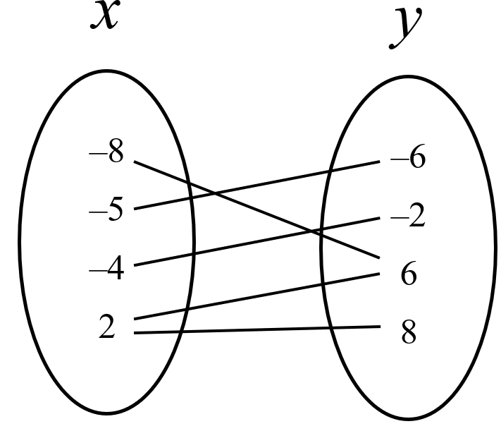
Ordered pairs:
Is the relation a function? Justify your answer.

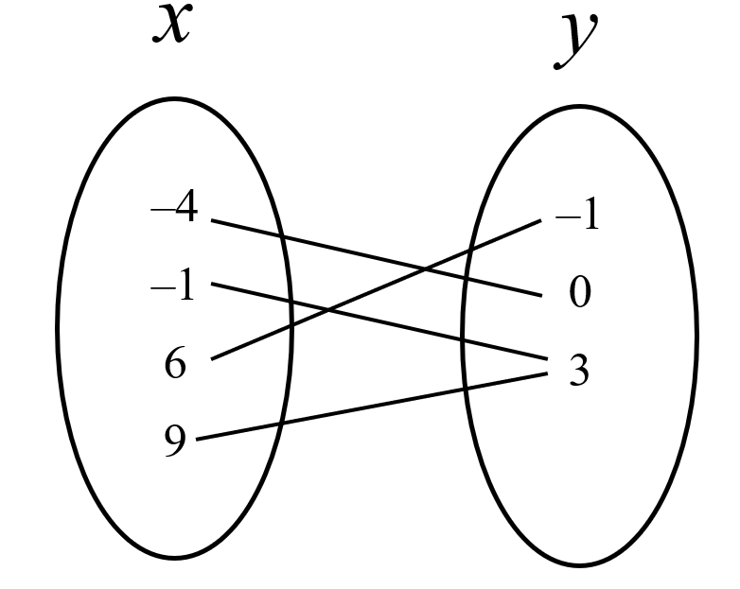
Ordered pairs:
Is the relation a function? Justify your answer.
Draw a mapping to represent the relation. You can
- Use shape tools to create the lines
- Draw using the annotation tools
- Create your mapping on scratch paper and insert an image
Then, determine if the relation is a function. Justify your answer.
- {(3,7) , (3,8) , (3,−2) , (−2,5) , (1,3) , (4,3)}

Is the relation a function? Justify your answer.

- {(−1,5) , (−2,−4) , (−3,−6) , (−4,7)}
Is the relation a function? Justify your answer.

Use the given table to write the relation as a table of values. Then, determine if the relation is a function. Justify your answer.
x | y
- {(1,–3), (6,2), (9,6), (1,5)}

Is the relation a function? Justify your answer.
- {(–1,1), (0,5), (3,5), (5,7)}
x | y

Is the relation a function? Why or why not?

Use the vertical line test to determine whether the graph is a function. Use the scribble tool or Insert Shapes and select a line if needed. Justify your answer.

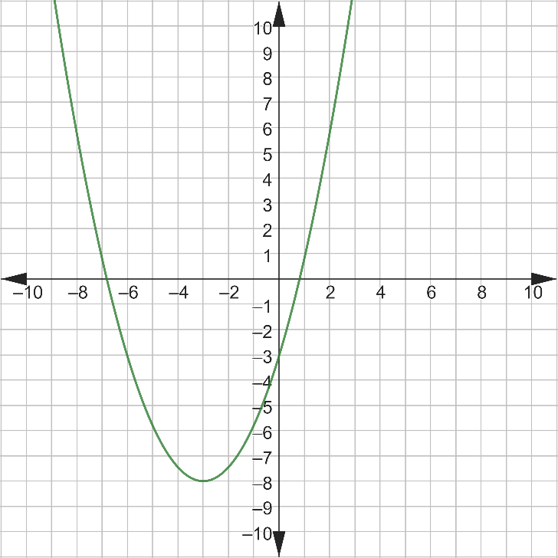
Is this a function? Justify your answer.

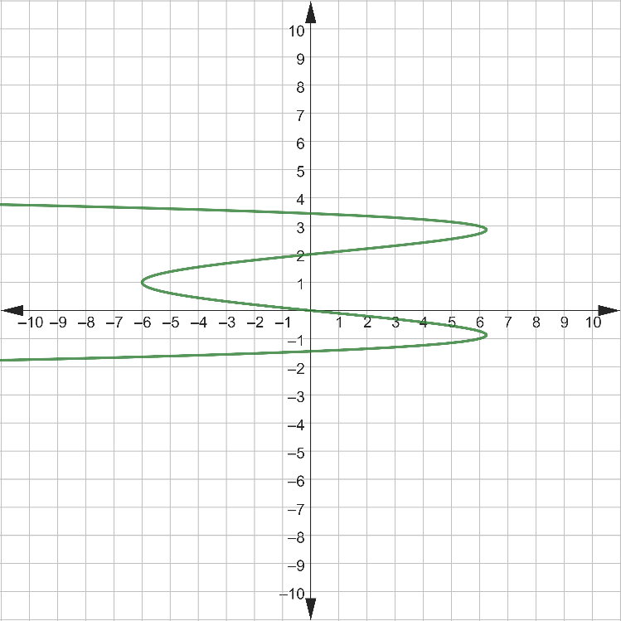
Is this a function? Justify your answer.

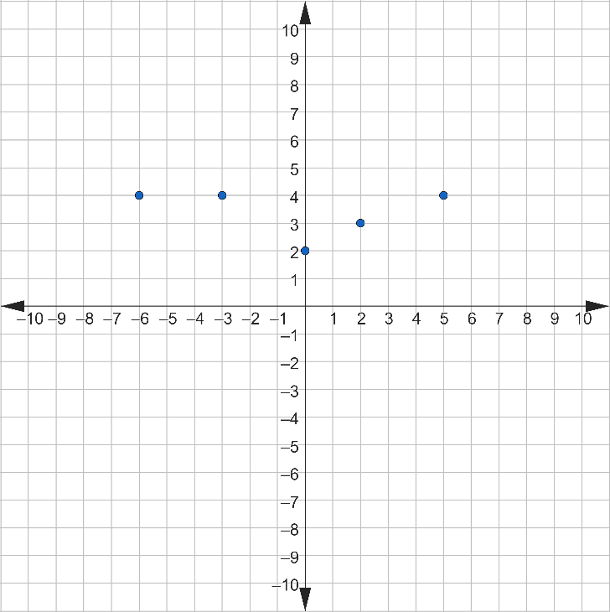
Is this a function? Justify your answer.

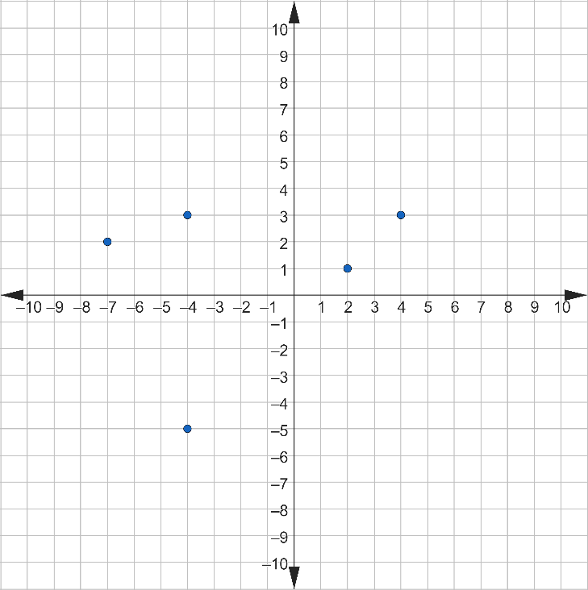
Is this a function? Justify your answer.

