Name:
Date:
School:
Facilitator:

2.03 Special Equations
Total Points: 36

Solve each equation. Show ALL solution steps.

- 4(m – 2) = 4m

- –4m + 5 = 5 – 4m

- 3(m + 1) – 5 = 3m – 2

- 2m – 9 = 2(m – 8) + 7

- 2m + 5 = 5(m – 7) – 3m

- 5m – 7 = 5(m – 2) + 3

- 7 – 3m = m – 4(2 + m)

- 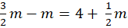

- 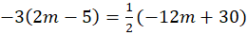

- 3m – 2(m + 3) = m

Create an equation for which the solution is no solution.

- Equation:

Create an equation for which the solution is all real numbers.

- Equation:

