Name:

Date:

School:

Facilitator:

1.06 The Coordinate Plane

Total Points: 60

This task requires you to create a graph. You have several options:

* Draw the graph by hand, then photograph or scan your graph;
* Use the Microsoft Word or Google Docs drawing tools to graph your data; or
* Use the GeoGebra linked on the Task page of the lesson to create the graph; then, insert a screenshot of the graph into this task.

**Plot each of these points. You can use the drawing tools in your word processing application, draw by hand and scan in, or insert a GeoGebra image. Make sure to label the points with the appropriate letters.**

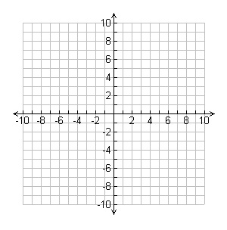1. Point M = (−2, 4)

2. Point O = (4, −2)

3. Point N = (4, 2)

4. Point E = (−2, −4)

5. Point Y = (−2, 0)

coordinate graph with points F, R, I, D, A, and Y**Find the coordinates for each point in this coordinate plane.**

6. Point F =

7. Point R =

8. Point I =

9. Point D =

10. Point A =

11. Point Y =

**Name the quadrant or on which axis would you locate each point.**

1. (−10, 6)

1. (−12, 0)
2. (8, −18)
3. (0, 30)
4. (−3, −8)

**Complete each statement.**

1. If the *x*−coordinate and the *y*−coordinate of an ordered pair are positive, the ordered pair is in which Quadrant?
2. If the *x*−coordinate of an ordered pair is negative, and the *y*−coordinate is positive, the ordered pair is in which Quadrant?
3. The *x*−coordinate is zero and the *y*−coordinate is negative. Is the point in Quadrant III? Explain.
4. The *y*−coordinate is zero and the *x*−coordinate is negative. Is the point in Quadrant II? Explain.